**S-131**



Published by the

International Hydrographic Organization

4b quai Antoine 1er

Principauté de Monaco

Tel: (377) 93.10.81.00

Fax: (377) 93.10.81.40

info@iho.int

www.iho.int

**IHO Marine Harbour Infrastructure (MHI) Product Specification**

**Edition 1.0.0.20221231 – December 2022**

|  |
| --- |
| © Copyright International Hydrographic Organization 2022 |
| This work is copyright. Apart from any use permitted in accordance with the [Berne Convention for the Protection of Literary and Artistic Works](http://www.wipo.int/treaties/en/ip/berne/trtdocs_wo001.html) (1886), and except in the circumstances described below, no part may be translated, reproduced by any process, adapted, communicated or commercially exploited without prior written permission from the International Hydrographic Organization (IHO). Copyright in some of the material in this publication may be owned by another party and permission for the translation and/or reproduction of that material must be obtained from the owner. |
| This document or partial material from this document may be translated, reproduced or distributed for general information, on no more than a cost recovery basis. Copies may not be sold or distributed for profit or gain without prior written agreement of the IHO Secretariat and any other copyright holders. |
| In the event that this document or partial material from this document is reproduced, translated or distributed under the terms described above, the following statements are to be included: |
| *“Material from IHO publication [reference to extract: Title, Edition] is reproduced with the permission of the IHO Secretariat (Permission No ……./…) acting for the International Hydrographic Organization (IHO), which does not accept responsibility for the correctness of the material as reproduced: in case of doubt, the IHO’s authentic text shall prevail. The incorporation of material sourced from IHO shall not be construed as constituting an endorsement by IHO of this product.”* |
| *“This [document/publication] is a translation of IHO [document/publication] [name]. The IHO has not checked this translation and therefore takes no responsibility for its accuracy. In case of doubt the source version of [name] in [language] should be consulted.”*  The IHO Logo or other identifiers shall not be used in any derived product without prior written permission from the IHO Secretariat. |

Contents

1 Overview 1

1.1 Introduction 1

1.2 Scope 1

1.3 References 1

1.3.1 Normative 1

1.3.2 Informative 1

1.4 Terms, definitions and abbreviations 2

1.4.1 Use of language 2

1.4.2 Terms and definitions 2

1.4.3 Abbreviations 6

1.5 General data product description 7

1.6 Data Product Specification metadata 8

1.7 IHO Product Specification maintenance 8

1.7.1 Introduction 8

1.7.2 New Edition 8

1.7.3 Revision 8

1.7.4 Clarification 9

1.7.5 Version numbers 9

2 Specification Scope 9

3 Dataset Identification 9

4 Data Content and Structure 10

4.1 Introduction 10

4.2 Application Schema 10

4.2.1 Domain model 11

4.2.2 Meta Features 30

4.2.3 Spatial Quality Information Type 31

4.2.4 Cartographic Features 32

5 Feature Catalogue 32

5.1 Introduction 32

5.2 Feature types 32

5.2.1 Geographic 32

5.2.2 Meta 32

5.2.3 Cartographic 32

5.3 Information types 32

5.3.1 Spatial quality 33

5.4 Feature and information relationships 33

5.5 Attributes 33

5.5.1 Simple attributes 33

5.5.2 Complex attributes 34

5.6 Units of measure 34

6 Coordinate Reference Systems (CRS) 35

6.1 Introduction 35

6.2 Horizontal Coordinate Reference System 35

6.3 Vertical CRS for Depths and Elevations 35

6.4 Projections 35

6.5 Temporal reference system 35

7 Datasets 35

7.1.1 Introduction 35

7.1.2 Dataset rules 35

7.1.3 Data Coverage rules 36

7.2 Display scale range 36

7.3 Geometry 36

7.3.1 S-131 geometry 36

7.3.2 Masking 37

7.3.3 Coordinate encoding in spatial primitives 37

8 Data Quality 37

8.1 Introduction 37

8.2 Quality measure elements 37

8.3 Test methods for data compliance and usability 40

8.4 Data quality testing and reporting 41

9 Data Capture and Classification 41

10 Maintenance 41

10.1 Introduction 41

10.2 Maintenance and update frequency 42

10.3 Data Source 42

10.4 Production Process 42

10.5 Feature and Portrayal Catalogue management 42

11 Portrayal 42

11.1 Introduction 42

11.2 Portrayal Catalogue 42

11.3 General rules and guidelines 43

11.3.1 The attribute *language* 43

11.3.2 Structured text in displays 43

11.4 Schedules 43

11.5 Limitations based on vessel dimensions and other characteristics 45

12 Data Product format (encoding) 45

12.1 Format specification 45

12.2 Encoding of latitude and longitude 46

12.3 Encoding of depths 46

12.4 Numeric attribute encoding 46

12.5 Text attribute values 46

12.6 Mandatory attribute values 46

12.7 Unknown attribute values 46

12.8 Object identifiers 46

12.9 Data coverage 47

12.10 Data overlap 47

12.11 Data quality meta-features 47

12.12 Data extent 47

12.13 Sequence of objects 47

12.14 Content of update datasets 47

12.15 Datum coverage 48

12.16 Attribute multiplicity 48

13 Data Product Delivery 48

13.1 Exchange set components 48

13.2 Encapsulation 50

13.3 Dataset 51

13.3.1 Types of Datasets 51

13.3.2 Dataset file naming 51

13.3.3 Update dataset naming convention 52

13.3.4 New Editions, re-issues, updates and cancellations 52

13.3.5 Exchange set structure 53

13.4 Support files 54

13.4.1 Support File Naming 55

13.4.2 Support file management 55

13.5 Exchange Catalogue 56

13.6 Dataset loading 56

13.6.1 New editions 56

13.7 Dataset size 56

13.8 Data integrity and encryption 57

14 Metadata 57

14.1 Introduction 57

14.2 Discovery metadata 57

14.2.1 S100_ExchangeCatalogue 60

14.2.2 S100_DatasetDiscoveryMetadata 62

14.2.3 S100_SupportFileDiscoveryMetadata 70

14.2.4 S100_CatalogueDiscoveryMetadata 73

14.2.5 Miscellaneous metadata types 75

14.2.6 Types for digital signatures 78

14.3 Language 78

LIST OF ANNEXES 79

**Document History**

Changes to this Specification are coordinated by the Nautical Information Provision Working Group, an IHO working group under HSSC. New editions will be made available via the IHO web site. Maintenance of the Specification shall conform to IHO Resolution 2/2007 (as amended).

|  |  |  |  |
| --- | --- | --- | --- |
| **Version Number** | **Date** | **Approved By** | **Purpose** |
| 1.0.0 | 2022-08-18 |  | Draft 1 |
| 1.0.0 | 2022-08-22 |  | Revised Draft 1 |
| 1.0.0 | 2022-11-25 | RM | Daft 2. Applied feedback from NIPWG after NIPWG9; added guidelines for portrayal of schedules and applicability; miscellaneous editorial revisions. |
| 1.0.0 | 2023-01-10 | RM | Added HarbourFacility to Figure 4.14; clarifications for ISO metadata and file naming; version date updated to sync. with other artefacts. |
|  |  |  |  |
|  |  |  |  |
|  |  |  |  |
|  |  |  |  |
|  |  |  |  |
|  |  |  |  |
|  |  |  |  |

# 

# Overview

## Introduction

S-131 is the Marine Harbour Infrastructure (MHI) Product Specification, produced by the International Hydrographic Organization. S-131 is designed to allow content, content definition (Feature Catalogues) and presentation (Portrayal Catalogues) to be updateable without breaking system implementations.

This document has been produced by the IHO Nautical Information Provision Working Group (NIPWG) in response to a requirement to produce a data product that can be used as a Nautical Publication Information Overlay (NPIO) within an Electronic Chart Display and Information Systems (ECDIS). It is based on the IHO S-100 framework specification and the ISO 19100 series of standards. It is a vector product specification that is intended for encoding information relating to port and harbour facilities for facilitating berth-to-berth navigation.

Marine Harbour Infrastructure (MHI) datasets describe the layout of ports and the availability of port services. This includes facility locations, service areas, services offered, and instructions for contacting or utilizing these services. MHI is intended to be a supplement to ENC, and therefore does not describe the geographic information in detail equal to ENC.

## Scope

This document describes an S-100 compliant Product Specification for Marine Harbour Infrastructure, which will form an overlay layer for an S-100 based marine navigation system. It specifies the content, structure, and metadata needed for creating a fully compliant S-131 product and for its portrayal within an S-100 system. This Product Specification includes the content model, the encoding, the Feature Catalogue, Portrayal Catalogue, and metadata.

## References

### Normative

ISO 639-2/T *Codes for the representation of names of languages – Part 2: Alpha-3 code*

ISO 3166-1 *Codes for the Representation of Names of Countries and their Subdivisions – Part 1: Country Codes*

M-3 Resolutions of the International Hydrographic Organization, IHO Publication M-3, 2nd Edition, 2010 (updated April 2022).

S-62 List of Data Producer Codes (online), URL: http://registry.iho.int/producercode/list.do

S-97 IHO Guidelines for Creating S-100 Product Specifications, Edition 1.1.0, June 2020.

S-98 Data Product Interoperability in S-100 Navigation Systems, Edition 1.0.0, May 2022

S-100 IHO Universal Hydrographic Data Model, Edition 5.0.0, December 2022.

### Informative

FIPS 186 *Federal Information Processing Standards – Digital Signature Standard*

IALA G1143 *Unique Identifiers for Maritime Resources*, Edition 3.0. International Association of Marine Aids to Navigation and Lighthouse Authorities, June 2021.

ISO 8601:2004 *Data Elements and Interchange Formats – Information Interchange – Representation of Dates and Times*

ISO 19101:2003 *Geographic Information – Reference Model*

ISO 19103:2005 *Geographic Information – Conceptual Schema Language*

ISO 19103-2:2005 *Geographic Information – Conceptual Schema Language – Part 2*

ISO 19108:2002 *Geographic Information – Temporal Schema*

ISO 19109:2005 *Geographic Information – Rules for Application Schema*

ISO 19110:2005 *Geographic Information – Methodology for Feature Cataloguing*

ISO 19111:2007 *Geographic Information – Spatial Referencing by Coordinates*

ISO 19115-1 *Geographic information – Metadata – Part 1 - Fundamentals*. As amended by Amendment 01 (2018)

ISO/TS 19115-3 *Geographic information - Metadata - XML schema implementation for fundamental concepts*

ISO 19117:2012 *Geographic Information – Portrayal*

ISO 19131:2008 *Geographic Information – Data Product Specifications*

ISO 19157:2013 *Geographic Information – Data Quality*

ISO/IEC 19501:2005 *Information Technology – Unified Modelling Language (UML)*, Version 1.4.2

ISO/IEC 19757-3 Information technology – Document Schema Definition Languages (DSDL) – Part 3: Rule-based validation – Schematron.

S-44 IHO Standards for Hydrographic Surveys, Edition 6.0.0, September 2020.

IHO S-58 ENC Validation Checks, Edition 7.0.0, October 2022.

IHO S-101 IHO Electronic Navigational Chart Product Specification Edition 1.1.0 (under development).

ITPCO Port Information Manual for Nautical Data of BIMCO, IAPH, IHMA, IHO, ITPCO

## Terms, definitions and abbreviations

### Use of language

Within this document:

* “Must” indicates a mandatory requirement.
* “Should” indicates an optional requirement, that is the recommended process to be followed, but is not mandatory.
* “May” means “allowed to” or “could possibly”, and is not mandatory.

### Terms and definitions

**Accuracy**

Closeness of agreement between a test result and the accepted reference values.

NOTE: A test result can be from an observation or measurement.

**Aggregation**

Special form of **association** that specifies a whole-part relationship between the aggregate (whole) and a component part.

**Alarm**

(MSC.302/A) a high-priority **alert**. Condition requiring immediate attention and action by the bridge team, to maintain the safe navigation of the ship.

**Alert**

(MSC.302/A) announcement of abnormal situations and conditions requiring attention. Alerts are divided in four priorities: **emergency alarm**s, **alarm**s, **warning**s and **caution**s. An alert provides information about a defined state change in connection with information about how to announce this event in a defined way to the system and the operator.

**Application Schema**

Conceptual schema for data required by one or more applications.

**Association**

Semantic relationship between two or more classifiers that specifies connections among their instances.

**Attribute**

(1) Named property of an entity.

NOTE: Describes a geometrical, topological, thematic, or other characteristic of an entity.

(2) Feature within a classifier that describes a range of values that instances of the classifier may hold.

NOTE: An attribute is semantically equivalent to a composition association; however, the intent and usage is normally different.

NOTE: “Feature” used in this definition is the UML meaning of the term.

**Boundary**

Set that represents the limit of an entity.

NOTE: Boundary is most commonly used in the context of geometry, where the set is a collection of points or a collection of objects that represent those points.

**Caution**

(MSC.302/A) lowest priority of an **alert**. Awareness of a condition which does not warrant an **alarm** or warning condition, but still requires attention out of the ordinary consideration of the situation or of given information.

**Class**

Description of a set of objects that share the same **attributes**, operations, methods, **relationships**, and semantics.

NOTE: A class represents a concept within the system being modelled. Depending on the kind of model, the concept may be real-world (for an analysis model), or it may also contain algorithmic and computer implementation concepts (for a design model). A classifier is a generalization of class that includes other class-like elements, such as data type, actor and component.

**Classification**

The process of determining the appropriate **data type** within a **feature catalogue** for a particular real world feature, including consideration of **data quality**.

**Coordinate**

One of a sequence of n numbers designating the position of a **point** in n-dimensional space.

NOTE: In a **coordinate reference system**, the coordinate numbers are qualified by units.

**Coordinate Reference System**

**Coordinate** system that is related to an object by a datum.

NOTE: For geodetic and vertical datums, the object will be the Earth.

**Coordinate Tuple**

Ordered list of **coordinates**.

**Curve**

1-dimensional **geometric primitive**, representing the continuous image of a line.

NOTE: The boundary of a curve is the set of points at either end of the curve. If the curve is a cycle, the two ends are identical, and the curve (if topologically closed) is considered to not have a boundary. The first point is called the start point, and the last is the end point. Connectivity of the curve is guaranteed by the "continuous image of a line" clause. A topological theorem states that a continuous image of a connected set is connected.

**Curve Segment**

1-dimensional geometric object used to represent a continuous component of a **curve** using homogeneous interpolation and definition methods.

NOTE: The geometric set represented by a single curve segment is equivalent to a curve.

**Data Product**

A **dataset** or dataset series that conforms to a data product specification.

**Data Quality**

A set of elements describing aspects of quality, including a measure of quality, an evaluation procedure, a quality result, and a scope.

**Data Type**

Specification of a value domain with operations allowed on values in this domain.

NOTE: Data types include primitive predefined types and user-definable types.

NOTE: A data type is identified by a term, for example Integer.

EXAMPLES: Integer, Real, Boolean, String, DirectPosition and Date

**Dataset**

An identifiable collection of data.

NOTE: A dataset may be a smaller grouping of data which, though limited by some constraint such as spatial extent or feature type,is located physically within a larger dataset. Theoretically, a dataset may be as small as a single feature contained within a larger dataset. A hardcopy map or chart may be considered a dataset.

**Datum**

Parameter or set of parameters that define the position of the origin, the scale, and the orientation of a **coordinate** system.

**Display Priority**

Hierarchy to determine which **feature** is to be displayed when two features overlap. Priority 2 overwrites 1.

**ECDIS**

A navigation information system which with adequate back-up arrangements can be accepted as complying with the up-to-date chart required by regulations V/19 and V/27 of the 1974 SOLAS Convention, as amended, by displaying selected information from a System Electronic Navigational Chart (SENC) with positional information from navigation sensors to assist the Mariner in route planning and route monitoring, and if required display additional navigation-related information.

**ENC**

The **dataset**, standardized as to content, structure and format, issued for use with **ECDIS** by or on the authority of a Government authorized Hydrographic Office or other relevant government institution, and conforming to IHO standards. The ENC contains all the chart information necessary for safe navigation and may contain supplementary information in addition to that contained in the paper chart which may be considered necessary for safe navigation.

**Enumeration**

A fixed list of valid identifiers of named literal values. **Attributes** of an enumerated type may only take values from this list.

**Feature**

Abstraction of real world phenomena.

NOTE: A feature may occur as a type or an instance. Feature type or feature instance should be used when only one is meant.

EXAMPLE: The phenomenon named ‘London Eye’ may be classified as a feature instance with other phenomena into a feature type ‘landmark’

**Feature Association**

**Relationship** that links instances of one **feature** type with instances of the same or a different **feature** type.

**Feature Attribute**

Characteristic of a **feature**.

NOTE: A feature **attribute** may occur as a type or an instance. Feature attribute type or feature attribute instance is used when only one is meant.

NOTE: A feature **attribute** type has a name, a **data type** and a domain associated to it. A feature **attribute** instance has an attribute value taken from the value domain of the feature **attribute** type.

NOTE: In a **feature catalogue**, a feature **attribute** may include a value domain but does not specify **attribute** values for feature instances.

EXAMPLE 1: A feature attribute named *communication channel* may have an attribute value *VHF0007* which belongs to the data type *text*

EXAMPLE 2: A feature attribute named *length* may have an attribute value *82.4* which belongs to the data type *real*

**Feature Catalogue**

A catalogue containing definitions and descriptions of the **feature** types, **feature attributes**, and **feature associations** occurring in one or more sets of geographic data.

**Geometric Primitive**

Geometric object representing a single, connected, homogeneous element of geometry.

NOTE: Geometric primitives are non-decomposed objects that present information about geometric configuration. They include points, curves, surfaces, and solids.

**Human Readable**

A representation of information that can be naturally read by humans.

**Identifier**

A linguistically independent sequence of characters capable of uniquely and permanently identifying that with which it is associated.

**Indication**

Visual indication giving information about the condition of a system or equipment.

**Instance**

Entity to which a set of operations can be applied and which has a state that stores the effects of the operations.

NOTE: See **feature**.

**Loxodrome**

A loxodrome is a line crossing all meridians at the same angle, that is, a path of constant bearing.

**Machine Readable**

A representation of information that can be processed by computers.

**Maximum Display Scale**

The larger value of the ratio of the linear dimensions of features of a dataset presented in the display and the actual dimensions of the features represented (largest scale) of the scale range of the dataset.

**Metadata**

Data about data.

**Minimum Display Scale**

The smaller value of the ratio of the linear dimensions of features of a dataset presented in the display and the actual dimensions of the features represented (smallest scale) of the scale range of the dataset.

**Model**

Abstraction of some aspects of universe of discourse.

NOTE: A semantically complete abstraction of a system.

**Multiplicity**

Specification of the number of possible occurrences of a property, or the number of allowable elements that may participate in a given relationship.

EXAMPLES: 1..* (one to many); 1 (exactly one); 0..1 (zero or one)

**Overscale**

The viewing scale is larger than the value considered by the data producer to be the largest intended (maximum) display scale for the data.

**Point**

0-dimensional **geometric primitive**, representing a position.

NOTE: The **boundary** of a point is the empty set.

**Portrayal Catalogue**

Collection of defined portrayals for a **feature catalogue**.

NOTE: Content of a portrayal catalogue includes portrayal functions, symbols, and portrayal context.

**Relationship**

Semantic connection among model elements.

NOTE: Kinds of relationships include association, generalization, metarelationship, flow, and several kinds grouped under dependency.

**Scale Minimum**

The smallest scale at which a feature is displayed (for example, a minor light, with a scale minimum of 1:45,000, would not be displayed at a scale of 1:90,000).

**Surface**

Connected 2-dimensional **geometric primitive**, representing the continuous image of a region of a plane.

NOTE: The boundary of a surface is the set of oriented, closed **curves** that delineate the limits of the surface.

**Symbol Size**

The size is specified in normalized units of 0.01 mm. The minimum dimension is always more than 4 mm. This size applies to display on a standard minimum screen.

**Text Label**

A textual description of a **feature**. Can be formatted to include standard text as well as **feature attribute** values. For example, light descriptions, place names etc.

**Transparent Fill**

A method of identifying features of **geometric primitive** **surface** by covering a given percentage of each 4 pixel square with the fill colour, leaving the remainder "transparent". Used to ensure the information underneath shows through.

**Vertical Datum**

Datum describing the relation of gravity-related heights or depths to the Earth.

**Warning**

(MSC.302/A) **alert** for condition requiring immediate attention, but no immediate action by the bridge team. Warnings are presented for precautionary reasons to make the bridge team aware of changed conditions which are not immediately hazardous, but may become so if no action is taken.

### Abbreviations

This product specification adopts the following convention for symbols and abbreviated terms.

CRS Coordinate Reference System

DCEG Data Classification and Encoding Guide

ECDIS Electronic Chart Display and Information System

ENC Electronic Navigational Chart

EPSG European Petroleum Survey Group

GFM General Feature Model

GML Geography Markup Language

IEC International Electrotechnical Commission

IHO International Hydrographic Organization

IMO International Maritime Organization

ISO International Organization for Standardization

JPEG Joint Photographic Experts Group

MRN Maritime Resource Name

MSVS Mariners Selected Viewing Scale

MHI Marine Harbour Infrastructure

NIPWG Nautical Information Provision Working Group

PNG Portable Network Graphics

SD System Database

SENC System Electronic Navigational Chart

SOLAS Safety of Life at Sea

SVG Scalable Vector Graphics

S-100WG IHO S-100 Working Group

TIFF Tagged Image File Format

UML Unified Modelling Language

URI Uniform Resource Identifier

URL Uniform Resource Locator

URN Uniform Resource Name

UTC Coordinated Universal Time

XML eXtensible Markup Language

XSD XML Schema Definition

XSLT eXtensible Stylesheet Language Transformations

## General data product description

NOTE: This information contains general information about the data product.

**Title:** Marine Harbour Infrastructure

**Abstract:** Marine Harbour Infrastructure (MHI) datasets describe the layout of port facilities and the availability of port services. MHI is intended to facilitate berth-to-berth navigation and voyage planning. MHI is intended to be a supplement to ENC, and therefore does not describe the geographic information in detail equal to an ENC.

**Content:** Datasets conforming to this specification will contain all relevant MHI information for the area of coverage. Additionally, there will be relevant metadata data quality, production authority, data sources, and publication date.

**Spatial Extent:**

**Description:** Global coverage of port and harbours and their environs.

**East Bounding Longitude:** 180°

**West Bounding Longitude:** -180°

**North Bounding Latitude:** 90°

**South Bounding Latitude:** -90°

**Purpose:** The purpose of an MHI dataset is to provide information to mariners for use in berth-to-berth navigation and voyage planning.

## Data Product Specification metadata

NOTE: The information in this clause identifies this Product Specification and provides information about its creation and maintenance. Dataset metadata is described in a separate clause.

**Title:** The International Hydrographic Organization Electronic Navigational Chart Product Specification

**S-100 Version:** 5.0.0

**S-131 Version:** 1.0.0

**Date:** December 2022

**Language:** English

**Classification:** Unclassified

**Contact:** International Hydrographic Organization

4b Quai Antoine 1er

B.P. 445

MC 98011 MONACO CEDEX  
Telephone: +377 93 10 81 00  
Fax: + 377 93 10 81 40

Email: [info@iho.int](mailto:info@iho.int)

**URL:** [www.iho.int](http://www.iho.int)

**Identifier:** S-131

**Maintenance:** Changes to the Product Specification S-131 are coordinated by the Nautical Information Provision Working Group, a technical group established by the International Hydrographic Organization, and are made available via the IHO web site. Maintenance of the Product Specification must conform to IHO Resolution 2/2007, as amended.

## IHO Product Specification maintenance

### Introduction

Changes to S-131 will be released by the IHO as a New Edition, revision, or clarification.

### New Edition

*New Editions* of S-131 introduce significant changes. *New Editions* enable new concepts, such as the ability to support new functions or applications, or the introduction of new constructs or data types. *New Editions* are likely to have a significant impact on either existing users or future users of S-131. All cumulative *revisions* and *clarifications* must be included with the release of approved New Editions.

### Revision

*Revisions* are defined as substantive semantic changes to S-131. Typically, *revisions* will change S-131 to correct factual errors; or introduce necessary changes that have become evident as a result of practical experience or changing circumstances. A *revision* must not be classified as a clarification. *Revisions* could have an impact on either existing users or future users of S-131. All cumulative *clarifications* must be included with the release of approved corrections revisions.

Changes in a *revision* are minor and ensure backward compatibility with the previous versions within the same Edition. Newer revisions, for example, introduce new features and attributes. Within the same Edition, a dataset of one version could always be processed with a later version of the Feature and Portrayal Catalogues.

In most cases a new Feature Catalogue will result in a *revision* of S-131.

### Clarification

*Clarifications* are defined as non-substantive changes. Typically, *clarifications*: remove ambiguity; correct grammatical and spelling errors; amend or update cross references; and insert improved graphics. A *clarification* must not cause any substantive semantic change to a data product.

Changes in a *clarification* are minor and ensure backward compatibility with the previous versions.

### Version numbers

The associated version control numbering to identify changes (n) to this Product Specification must be as follows:

New Editions denoted as **n**.0.0

Revisions denoted as n.**n**.0

Clarifications denoted as n.n.**n**

# Specification Scope

**Scope ID:** Global

**Level:** 006 - series

**Level name:** MHI Dataset

# Dataset Identification

A dataset that conforms to this Product Specification may be identified by its discovery metadata as defined in clause 14.

**Title:** Marine Harbour Infrastructure

**Alternate Title:** MHI

**Abstract:** S-131 datasets must be produced in accordance with the rules defined in the S-131 Product Specification. The S-131 Product Specification contains all the information necessary to enable producers to produce a consistent MHI dataset; and manufacturers to use that data efficiently within navigation systems.

**Topic Category:** Transportation (ISO 19115-1 MD_TopicCategoryCode 018)

**Geographic Description:** Ports and harbours in areas specific to marine navigation

**Spatial Resolution:** An MHI dataset must indicate a value for maximum display scale. Each **Data Coverage** feature must also carry a value for minimum display scale. Recommended values for scales can be found in the S-101 ENC Product Specification. Producers should note that at the smaller scales, geographic details within ports will have no perceptible visual separation on a graphic display, and are therefore encouraged to determine display scales taking into account the content and intended navigation purpose of the dataset.



**Purpose:** Information about ports and harbours for use in Electronic Chart Display and Information Systems

**Language:** English (Mandatory), other (Optional)

**Classification:** Data may be classified as one of the following:

1) Unclassified;

2) Restricted;

3) Confidential;

4) Secret;

5) Top Secret;

6) Sensitive but Unclassified;

7) For Official Use Only;

8) Protected; or

9) Limited Distribution.

**Spatial Representation Type:** Vector

**Point of Contact:** Producing Agency

**Use Limitation:** Not for sole use in navigation; must be used with an ENC.

# Data Content and Structure

## Introduction

The S-131 product is based on the S-100 General Feature Model (GFM), and is a feature-based vector product. Figure 4.1 shows how the S-131 application schema is realized from the S-100 GFM. All S-131 features and information classes are derived from one of the abstract classes **FeatureType** and **InformationType** defined in the S-131 application schema, which realize the GFM meta-classes S100_GF_FeatureType and S100_GF_InformationType respectively.

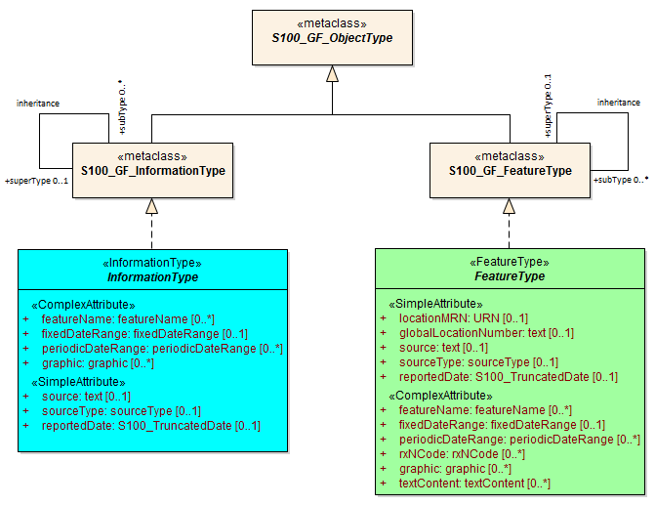

Figure 4.1 - Realizations from the S-100 General Feature Model

## Application Schema

S-131 conforms to the General Feature Model (GFM) from S-100 Part 3. This document describes the Application Schema expressed in UML. This document contains only an overview of the S-131 application schema. The S-131 Application Schema types are realised in the Feature Catalogue. The Feature Catalogue is included as a separate Annex (Annex C), and provides a full specification of all types including feature and information types, their attributes, allowed values, and relationships between types in the data product.

The following conventions are used in the UML diagrams depicting the application schema:

* Standard UML conventions for classes, associations, inheritance, roles, and multiplicities apply. These conventions are described in Part 1 of S-100.
* Italic font for a class name indicates an abstract class.
* Feature classes are depicted with green background; the dark shade for abstract feature classes and the light shade for ordinary (non-abstract) feature classes.
* Information type classes are depicted with blue background; the dark shade for abstract information type classes and the light shade for ordinary information types.
* Association classes are depicted with a white background.
* Complex attributes are depicted with a pink background.
* Enumeration lists and codelists are depicted with a tan background. The numeric code corresponding to each listed value is shown to its right following an ‘=’ sign.
* No significance attaches to the colour of associations. (Complex diagrams may use different colours to distinguish associations that cross one another.)
* Where the association role or name is not explicitly shown, the default rules for roles and names apply:
  + The role name is ‘the<CLASSNAME>’ where <CLASSNAME> is the name of the class to which that association end is linked.
  + The association name is ‘<CLASSNAME1>_<CLASSNAME2>’ where <CLASSNAME1> is the source and <CLASSNAME2> the target. In case of a feature/information association the feature is the source. For feature/feature or information/information associations without explicit names the source/target are indicated by an arrowhead.
* Subclasses inherit the attributes and associations of their superclasses at all levels, unless such inheritance is explicitly overridden in the subclass.

### Domain model

The S-131 domain model has two base classes (‘root classes’) from which all the domain-specific geographic features and information type classes are derived. The base classes are shown in Figure 4.2 below. The base class for geographic features is **FeatureType** and the base class for information types is **InformationType**. Each of the two base classes has a set of attributes which are therefore inherited by all domain-specific features. The approximate area features in S-131 are also derived from the geographic feature root class. Both base classes are abstract classes and do not have direct instances in S-131 data – instead, S-131 feature and information type data objects are instantiations of a non-abstract class derived from one of these base classes.

S-131 meta- and cartographic features are not derived from these base classes – S-131 instead incorporates meta- and cartographic feature definitions originally prepared for S-101 in the interests of harmonization and interoperability with other S-100-based data products, especially S-101 ENCs.

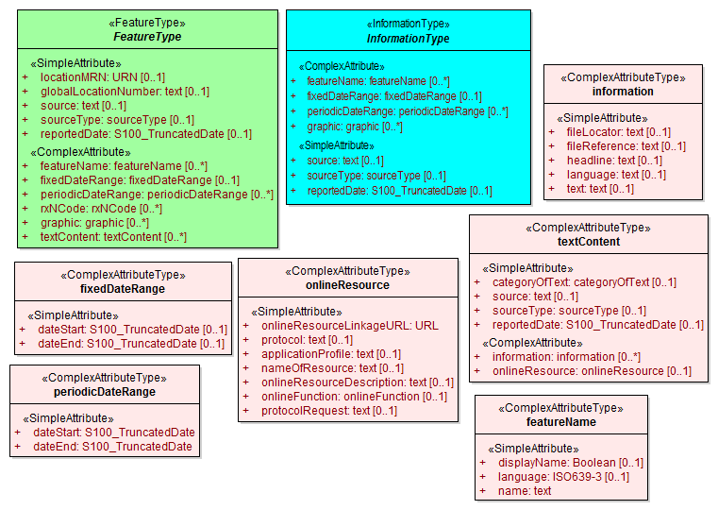

Figure 4.2 - Base classes in S-131

#### Overview of domain features and information types

Marine Harbour Infrastructure data products include harbour facilities, port services and specially designated areas related to ship operations in ports. It does not include protected areas, obstructions and other physical features, or natural conditions. The broad categories of geographic features and non-geographic information included in the S-131 domain are:

* Harbour layout, including the locations of terminals and berths, and contact information for terminal operators.
* Port services and related features such as waste reception facilities, supplies, fuel, and repair facilities.
* Supporting infrastructure such as the nature of nearby transportation.
* The locations of infrastructure such as dry docks and syncrolifts.
* Specially designated locations relating to manoeuvres, such as fairways and turning basins.

The geographic features are divided into “layout” and “physical infrastructure” classes, which are used as abstract generalizations of the domain feature classes. In addition, the **OrganizationContactArea**/**SupervisedArea** hierarchy used in other domain models for nautical publications are used as upper-level generalizations. Figure 4.3 depicts the hierarchy of domain feature classes.

Geographic features use spatial types defined in the geometry package for spatial attributes. Datasets comprised of S-131 features are described by metadata as defined in the S-131 metadata package.

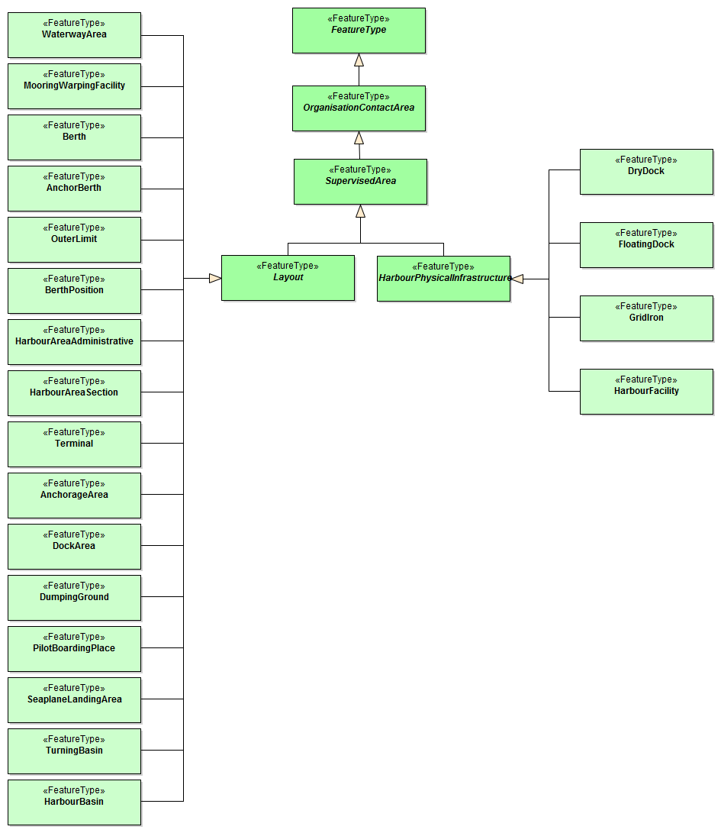

Figure 4.3 - Overview of S-131 domain feature classes

Information types model chunks of information associated to feature types. Information types may be associated to other information types or referenced by associations from feature types. The information types used in S-131 are depicted in Figure 4.4.

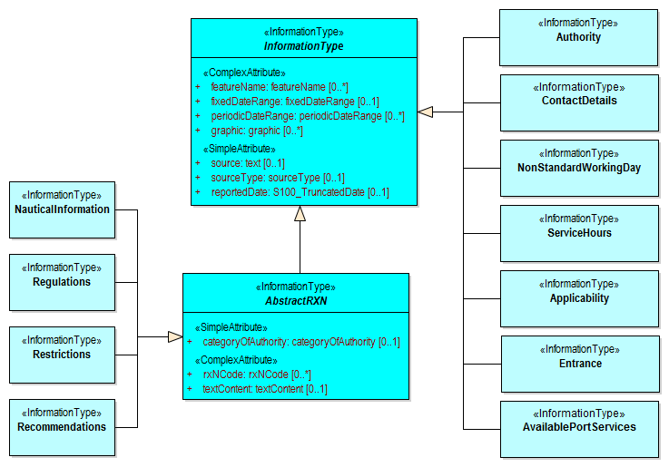

Figure 4.4 - Information types

The abstract class **FeatureType** is an abstract class from which the geographic feature classes in the application schema are derived. (Meta- and cartographic feature classes do not derive from it.) **FeatureType** has attributes for fixed and periodic date ranges indicating the effective dates of the feature, name of the feature, source information, types of regulations, and a **textContent** attribute that allows text notes or references to be provided for individual feature instances where appropriate. The attributes defined in **FeatureType** are inherited by all S-131 geographic feature types. All the attributes in **FeatureType** are optional. A derived class may impose additional constraints, which will be described in the definition of the derived class or the S-131 DCEG. Figure 4.5 depicts **FeatureType** and its attributes.

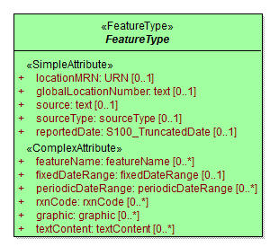

Figure 4.5 - The root class FeatureType

The abstract class **InformationType** is an abstract class from which all the information type classes in the S-131 domain model (except **SpatialQuality**) are derived. **InformationType** has attributes for fixed and periodic date ranges, name associated with the individual information object if any, source information, and a **textContent** attribute that allows text notes or references to be provided for individual instances where appropriate. The attributes defined in **InformationType** are inherited by all S-131 information type classes. All the attributes of **InformationType** are optional. A derived class may impose additional constraints, which will be described in the definition of the derived class or in the S-131 DCEG. Figure 4.6 depicts **InformationType** and its attributes.

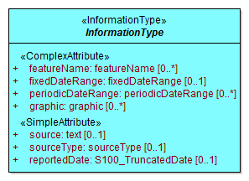

Figure 4.6 - The root class InformationType

#### Layout

Layout features describe the layout of the harbour area. They include terminal, mooring facilities, special areas within the harbour, berths, designation of the positioning of specific berths along a wharf or quay, dock areas, and a **HarbourAreaSection** feature for subdividing harbour areas into sub-sections.

Note that the current model includes some features which would ideally be merged into “categoryOfPortSection” attributes of other features, due to GI Registry conceptual limitations on re-use of concepts.

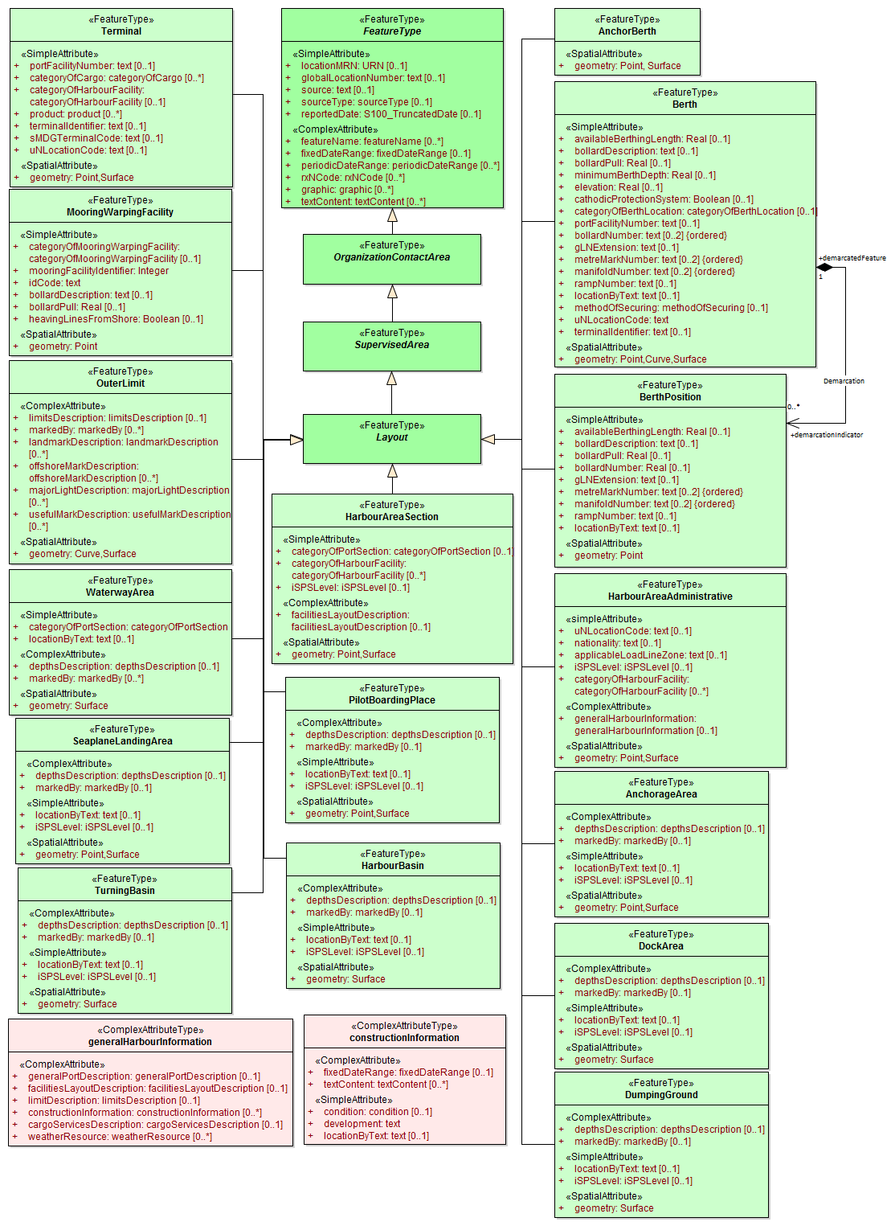

Figure 4.7 - Layout features

#### Physical Infrastructure

Physical infrastructure features include drydock and floating dock facilities, ship lifts, gridirons, and straddle carriers. The features are depicted in Figure 4.8. Note that “ship lift” and “straddle carrier” are modelled as **HarbourFacility** features with a category attribute, due to current GI Registry conceptual limitations on the use of these concepts.

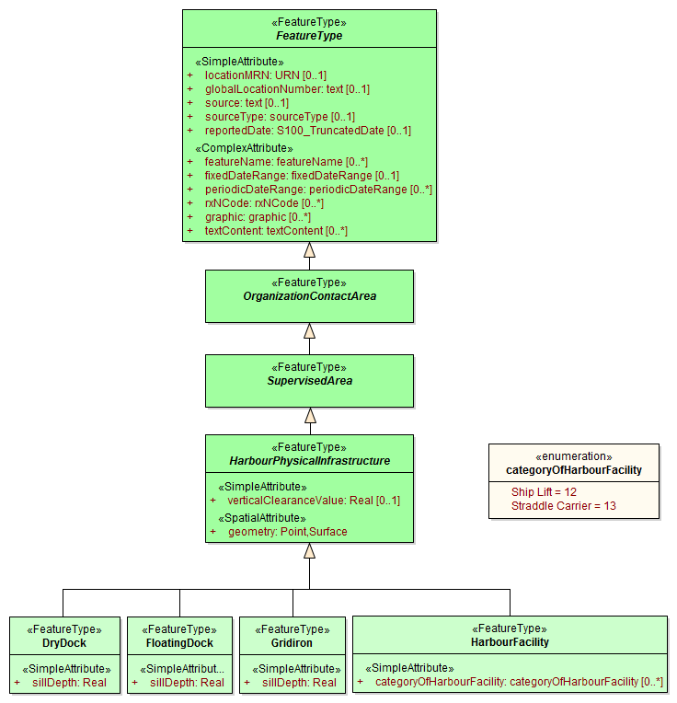

Figure 4.8 - Physical Infrastructure features

#### Services

Information about the services available in specific areas is modelled by means of an information association from the feature to the **AvailablePortServices** information type. This relationship is depicted in Figure 4.9. This type contains attributes for encoding various types of services. Examples of the service enumerations are depicted in Figure 4.10

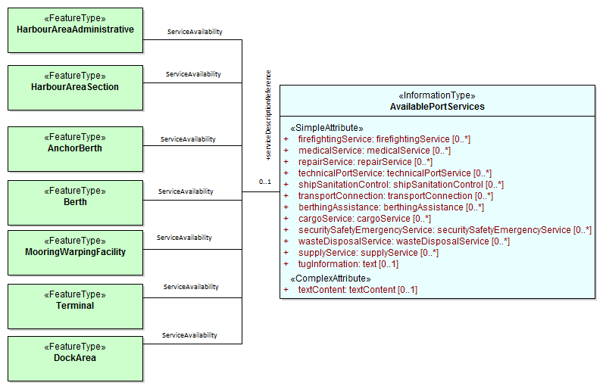

Figure 4.9 - Port Services

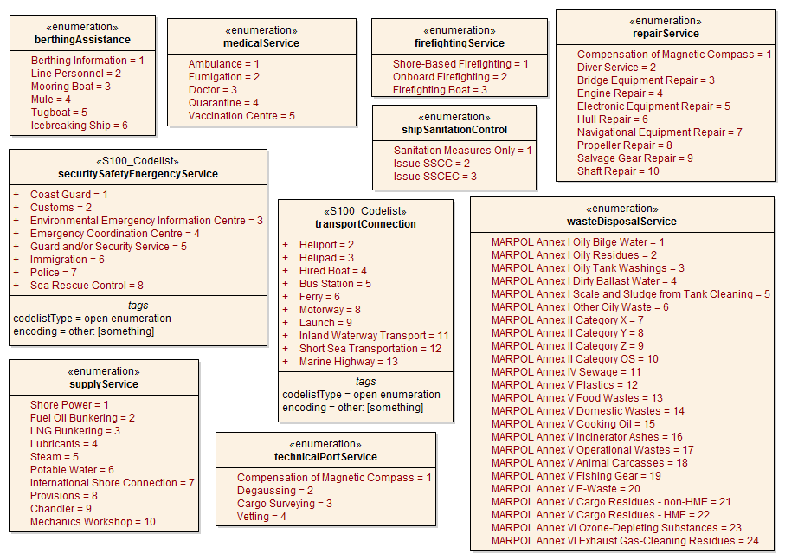

Figure 4.10 - Service Enumerations and Codelists

#### Regulations

There are three main information types which represent regulations, restrictions, and recommendations, respectively, and a fourth information type for general or unclassifiable information.

* The **Regulations** class represents information derived from port regulations, rules made by terminal operators, laws, national shipping regulations, navigation rules, etc.
* Class **Restrictions** is intended for restrictions that are not derived from regulatory sources.
* Class **Recommendations** is intended for information that is recommendatory in nature; in S-131 this may be recommendations for the orientation of vessels relative to the wharf while docking and similar pieces of information that are either voluntary or have not been issued as formal rules by the port authority or terminal operator.

The fourth class, **NauticalInformation**, is intended for general notes or other information that cannot be categorized as one of the other three classes.

These information types all inherit the attributes of their immediate abstract superclass **AbstractRxN**, which provides attributes **textContent** and **graphic** for textual and pictorial material respectively. The sub-attributes of its complex attribute **rxnCode** allow optional classification of the material encoded in **textContent**/**graphic** according to the type of material and the kind of nautical activity affected by it. They also inherit the attributes of abstract superclass **InformationType**, which allows encoding of the effective and expiry dates, if any, and the source of information[1], if it is necessary to encode that data.

These classes are intended primarily for encoding textual information, such as that which derives from textual source material such as port handbooks, national or local laws or official publications.

The use of these information types to associate regulatory and other information to individual features is described elsewhere (Clause 4.2.1.8). Figure 4.11 depicts the **Regulations**, **Restrictions**, **Recommendations**, and **NauticalInformation** classes, their class hierarchy, and the attributes of their generalizations **AbstractRxN** and **InformationType** (which are inherited by the classes).

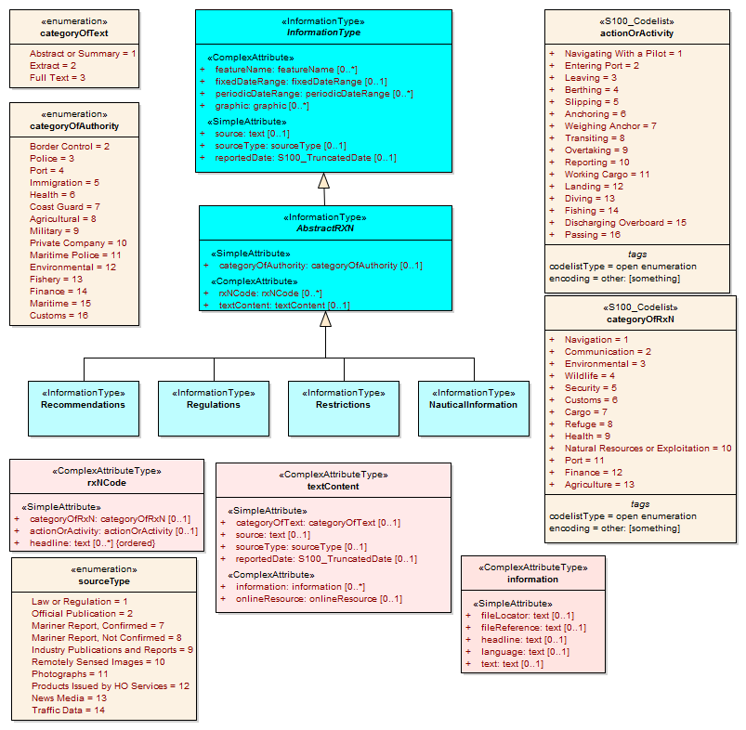

Figure 4.11 - Regulations and other information types for primarily textual information

#### Contact information

The detailed model of contact information is shown in Figure 4.12 below.

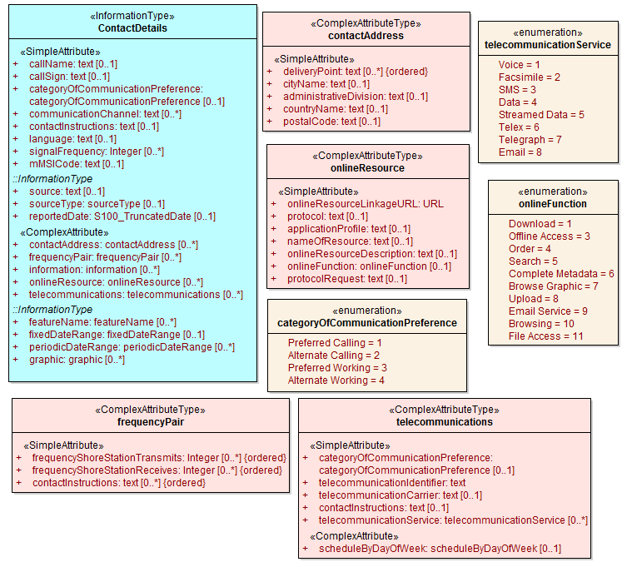

Figure 4.12 - Contact information

Contact information can be associated to an instance of an **Authority** information type as well as to any feature that is a subtype of **OrganizationContactArea,** which means any S-131 geographic feature (meta and cartographic features do not allow this association). Figure 4.13 shows the associations to **ContactInformation**.

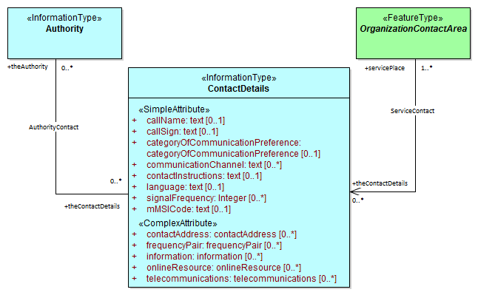

Figure 4.13 - Associations to contact information

#### Supervising organizations and their service hours

The **SupervisedArea** class models areas which may have an associated organization (government or private) that exercises some kind of control or supervision over the area.

Operating schedules and business hours of organizations are modelled by associating the **ServiceHours** class to an **Authority**. The **ServiceHours** class is a container for the complex attribute describing daily schedules for different weekdays (**scheduleByDayOfWeek**). This complex attribute contains another complex attribute for time intervals and the days to which they apply, and category sub-attribute to model whether the schedule describes opening hours, closures, etc. Exceptions to the schedule such as fixed or movable holidays are modelled by a **NonStandardWorkingDay** class with attributes allowing indication of the dates or days which are holidays or exceptions.

Working times and schedules for particular features are modelled by an analogous association from the feature object (association **LocationHours**). When a **ServiceHours** is thus linked to a service feature, the service hour information applies to the feature as a whole (e.g., all services for a **Terminal**). Note that since working hours do not apply to all features in the model, the associations are to individual features instead of abstract supertypes.

Working times of 24 hours/day may be explicitly encoded (from 00:00:00 to 24:00:00 hrs., in accordance with ISO 8601 conventions for midnight at the beginning and end of a day).

The model for both kinds of schedules is shown in Figure 4.13.

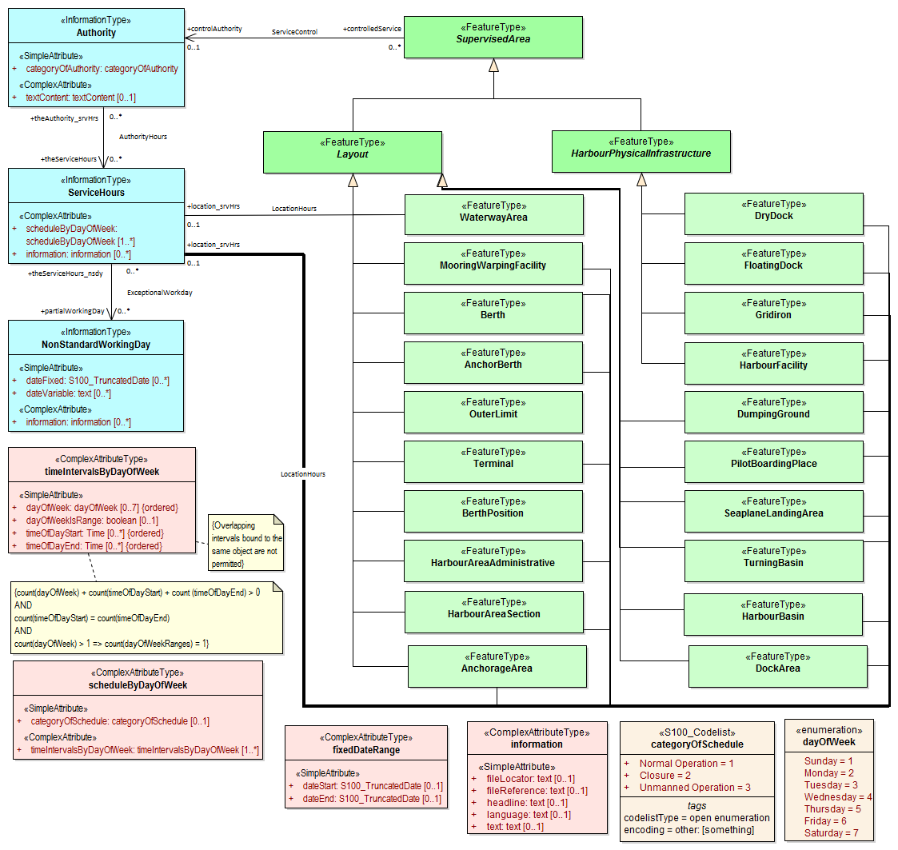

Figure 4.14 - Working times and schedules

The authority should be encoded only if its presence in the dataset conveys information that is useful to the end user. In S-131 this is expected to be the general case, but there may be exceptions, such as when the authority is open for business but a particular location under its jurisdiction is closed at certain times of day.

Since **Authority** also has an information association to **ContactDetails** (Figure 4.13), it is in principle possible to link a location to both an **Authority** and **ContactDetails** as well as linking the location to the same **ContactDetails**. Such linking is permissible but will generally be redundant and should, if possible, be avoided as unnecessary duplication. It may be done in situations where contact details for an operating authority are different from contact details for the service it operates.

Figure 4.13 also shows associations between service features and **Authority**. **Authority**-**ContactDetails** associations are omitted to reduce clutter.

#### Regulations applying in specific locations

The **AssociatedRxN** association between a feature type and a **Regulations**, **Restrictions**, **Recommendations**, or **NauticalInformation** object (see Figure 4.14) indicates that the Regulation, etc., is applicable within the associated feature. If it is necessary to identify an authority or organization related to a particular regulation (restriction, etc.) object, this may be done using the **RelatedOrganisation** association between **Regulations**, etc., and an **Authority** object. This should be included only when the connection to the **Authority** conveys useful information to the end user – it is not intended to encode the issuing or controlling authority for every regulation. Note also that while **Authority** can be associated to geographic features as well as **Regulations**, etc., encoding both associations is not mandatory even when the same **Authority** is associated to a service area as well as a **Regulations** object (or **NauticalInformation**, etc.).

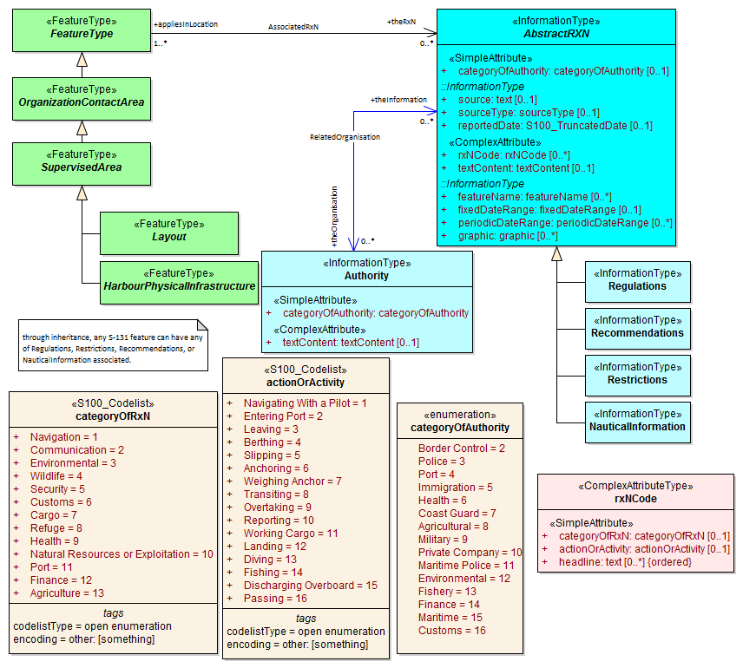

Figure 4.15 - Regulations, etc., applying to specific features

#### Regulations applying only to vessels with specific characteristics or cargoes

Certain regulations apply only to vessels of specified dimensions, types, or carrying specified cargo, etc.

This is modelled by first defining the relevant subset of vessels according to the dimension, type, cargo, etc., and then associating that subset to the appropriate feature or information type. The subset of vessels is modelled using the **Applicability** class, which contains attributes for the most common vessel characteristics used in nautical publications. These include measurements (length, beam, draught), type of cargo, displacement, etc. Constraints which cannot be modelled using the attributes of **Applicability** can be described in plain text in its **information** attribute.

Conditions relating to vessel dimensions are modelled by the complex attribute **vesselsMeasurements**, which has sub-attributes for naming the dimension and indicating the limit (whether the condition applies to a vessel which exceeds or falls below the limit). For example, the combinations below describe the condition “length overall > 50 m” (Condition 1) and “length overall < 90 m” (Condition 2):

Table 4.1 - Conditions relating to vessel dimensions

|  |  |  |  |
| --- | --- | --- | --- |
|  | **Condition 1** | **Condition 2** | **Condition 3** |
| **vesselsCharacteristics** | length overall | length overall | breadth |
| **comparisonOperator** | greater than | less than | greater than |
| **vesselsCharacteristicsValue** | 50 | 90 | 20 |
| **vesselsCharacteristicsUnit** | metre | metre | metre |

The **logicalConnectives** attribute is used to indicate how to interpret the case where multiple conditions are encoded using attributes of measurements - whether the conditions described by condition attributes are cumulative (conjunctive, AND) or alternatives (disjunctive, OR). A **logicalConnectives**=AND combined with Conditions 1 and 2 above describes a vessel of length between 50 and 90 metres; **logicalConnectives**=OR combined with conditions 1 and 3 describes a vessel of length greater than 50 metres or beam greater than 20 metres.

This modelling cannot represent subsets defined by both AND and OR combinations of conditions, but it is always possible to convert such complex conditions into multiple combinations each using only AND (‘conjunctive normal form’) or OR (‘disjunctive normal form’), and model the subset using more than one **Applicability** object. Multiple instances of Applicability associated to the same feature or information type are interpreted as alternatives (inclusive OR).

Figure 4.15 depicts the classes and attributes that can be used to define subsets of vessels according to specified characteristics.

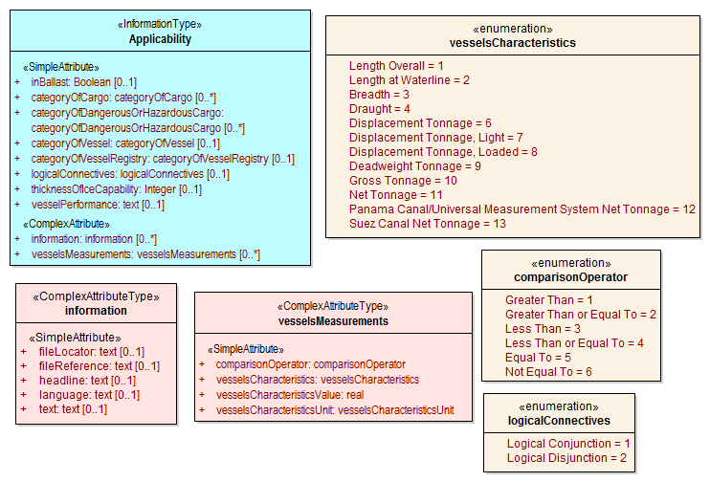

Figure 4.16 - Vessel subsets characterised by cargo, dimensions and capabilities

Given the relevant subset of vessels, it can be associated to the appropriate feature, regulation, or report by a **PermissionType**, or **InclusionType** association. These are association classes, whose single attribute models the nature of the relationship between the vessel subset and feature or information type. Figure 4.16 depicts the use of vessel subsets in **PermissionType** or **InclusionType** associations.

The association classes **PermissionType** and **InclusionType** basically characterize the relationship. For example:

1. A specified set of vessels is COVERED by a regulation and another set of vessels is EXEMPT from the regulation.
2. Vessels with specified cargo and dimensions MUST use a specified berth, vessels of smaller dimensions are RECOMMENDED to use the berth, and naval transports are EXEMPT from using the berth.

“COVERED” and “EXEMPT” are different kinds of relationship between different subsets of vessels characterized by different dimensional limits, etc., and a given regulation.

“MUST use”, “RECOMMENDED to use”, and “EXEMPT from use” are relationships between different subsets of vessels characterized by different dimensional limits, etc., and a given feature or service.

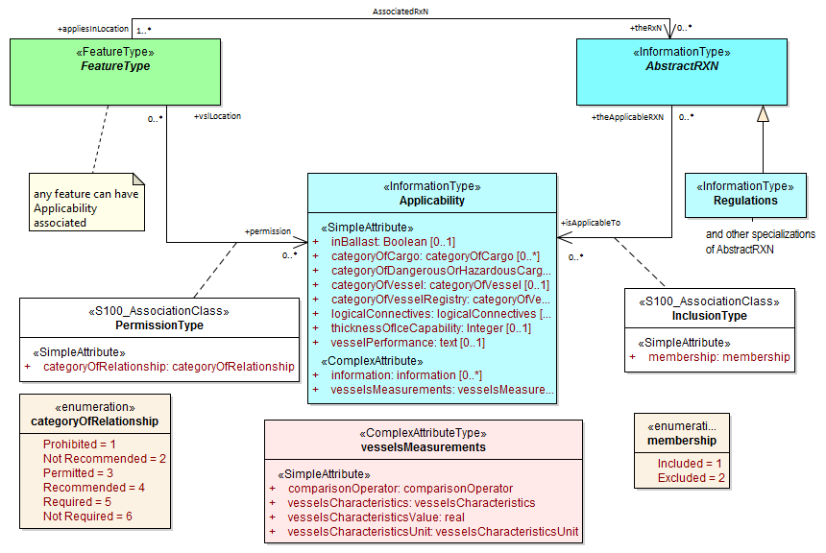

Figure 4.17 - Applicability of rules, etc., to vessel categories

**PermissionType** links a feature to an **Applicability**, and models a requirement, recommendation or prohibition on entry into a feature, by the specified subset of vessels.

**Inclusion** links a **Regulation**, **Recommendation**, **Restriction**, or **NauticalInformation** instance to a subset defined by an Applicability object, and indicates whether the content of the **Regulation**, etc., applies to the vessels (membership=included), or whether it explicitly does not apply (membership=excluded).

Informally:

a) **Applicability** describes the set of vessels: i.e., who

b) **Regulations** provides the text of the regulation: i.e., what

c) The association class **InclusionType** describes the relationship between who and what. That is, who “must (or can)” / “need not” do what.

And:-

d) A geographic feature defines a location or physical facility: i.e., where

e) The association class PermissionType describes the relationship between who and where. That is, who can / must / should / need not use (or sail) where.

#### Other uncategorized supplementary information

The domain model also provides a method for attaching to any feature or information type data in the form of a text note, graphic, or Internet reference which cannot be categorized using an appropriate feature or information type. This consists of defining a **NauticalInformation** object and referencing it from the feature or information type using the **AdditionalInformation** association. This method is intended to be a last resort and every effort should be made to use a more specific feature or information type to encode the information to be attached, including splitting the information in question across more than one type of feature or information object as needed and/or using the **AssociatedRxN** association instead of **AdditionalInformation**, wherever the nature of the content allows it. See Figure 4.17..

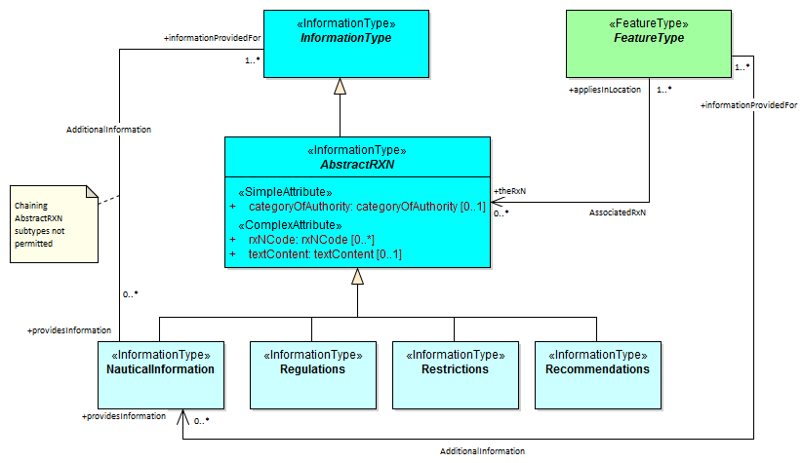

Figure 4.18 - Attachment of uncategorizable information to any feature or information type

#### “Wrapper” complex attributes

S-131 provides a general method for encoding some kinds of information using “wrapper” attributes that are basically a named type of text content. The information is encoded in narrative form in a **textContent** sub-attribute, which provides a general way to encode textual information. Figure 4.18 depicts the wrapper attributes.

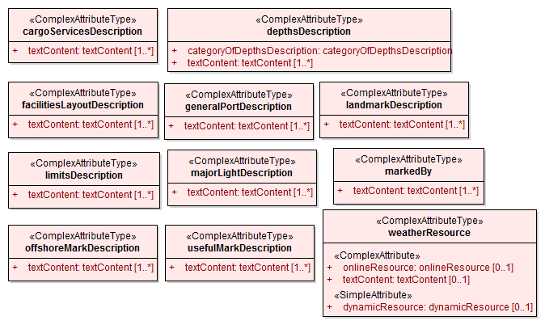

Figure 4.19 - Wrapper Attributes

#### Feature relationships

Feature relationships in S-131 are depicted in Figure 4.19. The feature relationships can be generally characterized as follows:

**HarbourAreaAdministrative** is the main feature that covers the whole port area. It is subdivided into zero or more sections modelled by **HarbourAreaSection** features (the **LayoutDivision**) aggregation. **HarbourAreaSection** can be further subdivided into **WaterwayArea**, **Terminal**, **Berth**, **AnchorageArea**, **DockArea**, etc. The **Terminal** feature can also be subdivided into **Berth** features using the same association.

**HarbourAreaSection** can also be subdivided into further features of the same class (the **SubUnit** self-association).

Nominal positions of berths can be indicated by associating a **BerthPosition** feature to **Berth** using the **Demarcation** association.

Berth positions and Anchor berths can be linked to a mooring facility using the **PrimaryAuxiliaryFacility** association.

Physical infrastructure features in a Terminal or **HarbourAreaSection** feature should be linked to its container **Terminal** or **HarbourAreaSection** by an **Infrastructure** association. If there is an hierarchy of features containing the infrastructure only the feature at the lowest level of the hierarchy should be linked to the infrastructure feature.

The outer limit of the whole harbour area can be associated to **HarbourAreaAdministrative** feature using a **JurisdictionalLimit** association.

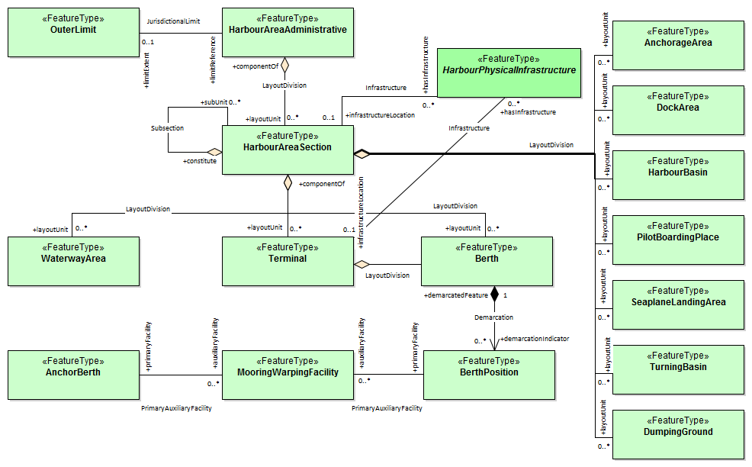

Figure 4.20 - Relationships between geographic features

### Meta Features

S-131 provides four meta-features:

* **DataCoverage** for describing areas in the cell that are populated with data. If the cell must include distant areas that are not part of the port area, such areas will generally be excluded from the **DataCoverage** feature(s).
* **QualityOfNonbathymetricData** for encoding quality information.
* **SoundingDatum** and **VerticalDatum** for encoding information about the datums for depths and elevations respectively.

Figure 4.20 depicts the meta-features and their attributes.

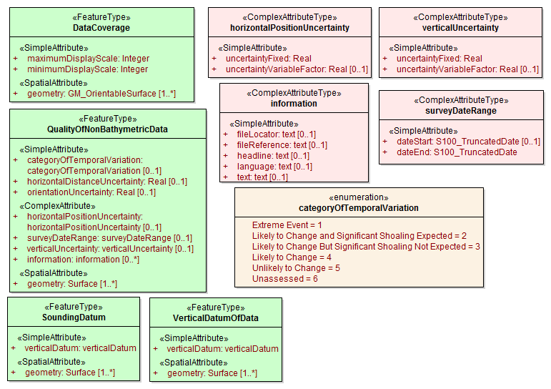

Figure 4.21 - Meta-feature classes

### Spatial Quality Information Type

S-131 spatial quality of spatial primitives is encoded in the SpatialQuality information type, which is associated to spatial objects. The modelling is the same as in S-101. The attributes describe qualitative and quantitative horizontal quality. See Figure 4.21.

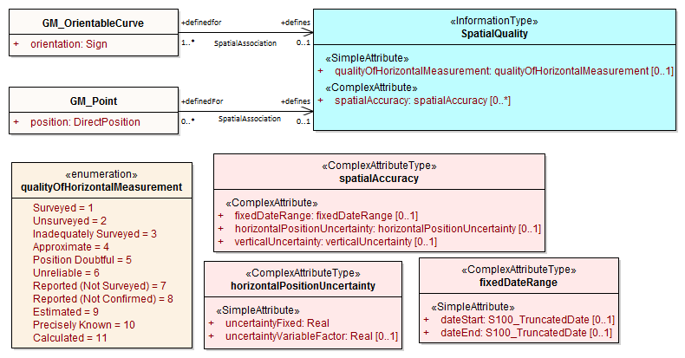

Figure 4.22 - Spatial Quality

### Cartographic Features

S-131 utilizes a single cartographic feature called TextPlacement that is to optimise text positioning, such as at smaller scales to prevent cluttering. This feature can be associated to any geographic feature and gives the location of a text string relative to the location of the feature. The modelling and use are the same as in S-101. See Figure 4.22.

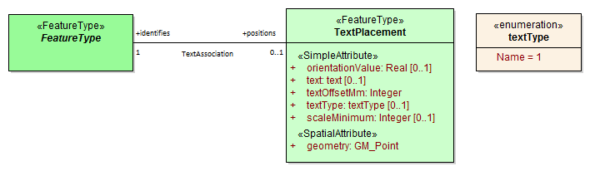

Figure 4.23 - Text Placement

# Feature Catalogue

## Introduction

The Feature Catalogue describes the feature types, information types, attributes, attribute values, associations and roles which may be used in the product. The S-131 Feature Catalogue is available in an XML document which conforms to the S-100 XML Feature Catalogue Schema and can be downloaded from the IHO Geospatial Information Registry website (https://registry.iho.int/).

## Feature types

Feature types contain descriptive attributes that characterize real-world entities. The word ‘feature’ may be used in one of two senses – feature type and feature instance. A feature type is a class and is defined in a Feature Catalogue. A feature instance is a single occurrence of the feature type and represented as an object in a dataset. A feature instance is located by a relationship to one or more spatial instances. A feature instance may exist without referencing a spatial instance.

### Geographic

Geographic (geo) feature types carries the descriptive characteristics of a real-world entity (a location or place on the surface of the Earth). In the context of hydrographic products, this includes the adjacent regions from the sea floor to elevations of landforms and structures above the Earth’s surface.

### Meta

Meta features contain information about other features within a dataset. Information defined by meta features override the default metadata values defined by the dataset descriptive records. Meta attribution on individual features overrides attribution on meta features.

### Cartographic

Cartographic features contain information about the cartographic representation (including text) of real world entities.

## Information types

Information types define identifiable pieces of information in a dataset that can be shared using information associations. They have attributes but have no geometry.

### Spatial quality

Spatial quality attributes are carried in an information class called **SpatialQuality** (Figure 4.21) Only points and curves can be associated with spatial quality. Currently no use case for associating surfaces with spatial quality attributes has been identified, therefore this is prohibited. Vertical uncertainty is prohibited for curves as this dimension is not supported by curves.

## Feature and information relationships

A feature relationship links instances of one feature type with instances of the same or a different feature type.

An information relationship links instances of feature types or information types to instances of information types.

## Attributes

S-131 defines attributes as either simple or complex.

### Simple attributes

S-131 uses seven types of simple attributes; they are listed in the following Table:

Table 5-1 – Simple attribute types

|  |  |
| --- | --- |
| **Type** | **Definition** |
| Boolean | A logical value, either ‘True’ or ‘False’ |
| Integer | An integer number |
| Real | A floating point number |
| Enumeration | One of a list of predefined values |
| Text or CharacterString | General text. |
| Date | A date gives values for year, month and day according to the Gregorian Calendar.  In XML formats including S-131, the XML Schema standard type should be used instead of the ISO 8601 basic representation (which is not a standard type in XML).  EXAMPLE: 1998-09-18 |
| Truncated Date | A S100_TruncatedDate allows a date or partial date to be given. At least one of the year/month/day components must be present. Since S-131 uses XML formats for both dataset and metadata, the XML encoding of truncated dates must be used (i.e., the ISO 8601 basic format is not used in S-131).  Components:  YYYY Year integer between 0000 and 9999  MM Month integer between 01 – 12 (inclusive)  DD Day integer between 01 and 28, 29, 30, or 31 (inclusive), consistent with year and month values if these are specified  This type can be used to encode recurring instants (see S-100 Part 3, clause 3-8).  EXAMPLE: The appropriate XML Schema type should be used:  --12-17 representing 17 December of any year (conforming to the XML type gMonthDay)  S-100 Part 10b provides further details about encoding in GML datasets. |
| Time | A 24-hour time, it may contain a time zone. Since S-131 uses XML formats for both datasets and metadata, the XML encoding must be used.  In XML formats (including S-131), the XML Schema standard type should be used instead of the ISO 8601 basic representation (which is not a standard type in XML). EXAMPLES:  18:30:59Z (local time in UTC);  18:30:59+01:00 (local time with given offset);  18:30:59 (local time without an offset to UTC). |
| Codelist | A type of flexible enumeration. A code list type is a list of literals which may be extended only in conformance with specified rules. |
| URI | A uniform resource identifier as defined in RFC 3986. Character encoding of a URI shall follow the syntax rules defined in RFC 3986.  EXAMPLE http://registry.iho.int |
| URL | A uniform resource locator (URL) is a URI that provides a means of locating the resource by describing its primary access mechanism (RFC 3986).  EXAMPLE http://registry.iho.int |
| URN | A persistent, location-independent, resource identifier that follows the syntax and semantics for URNs specified in RFC 2141.  EXAMPLE urn:iho:s101:1:0:0:AnchorageArea |

### Complex attributes

Complex attributes are aggregations of other attributes that are either simple or complex. The aggregation is defined by means of attribute bindings. Bindings of complex attributes are represented in the S-131 UML diagrams by a local attribute (Figure 5.1, **HarbourAreaAdministrative** /*generalHarbourInformation* attribute, *generalHarbourInformation*/*weatherResource* attribute as well as other complex attributes whose internal details are not shown in this figure).

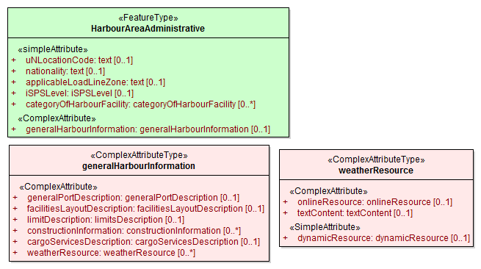

Figure 5.1 - Complex attribute

EXAMPLE: In the left example the complex attribute **topmark** has three sub attributes, one of which (**shape information**) is itself complex. The **Buoy Lateral** feature may optionally include one instance of **topmark**. In the right example the **Buoy Cardinal** feature may optionally include one instance of **topmark** (as for the left example) and one or more instances of **feature name**.

## Units of measure

The following units of measure are used in Marine Harbour Infrastructure datasets;

* Orientation is given in decimal degrees
* Radio frequency is given in hertz
* Uncertainty is given in metres
* Distances are given in metres or nautical miles
* Depths are given in metres.

The feature catalogue specifies the unit of measure for each attribute for which a unit is needed.

# Coordinate Reference Systems (CRS)

## Introduction

An MHI dataset must define one geodetic CRS and one vertical CRS each for depths and elevations.

## Horizontal Coordinate Reference System

The horizontal CRS must be EPSG:4326 (WGS84). The full reference to EPSG: 4326 can be found at [www.epsg-registry.org](http://www.epsg-registry.org).

**Horizontal Coordinate Reference System:** EPSG:4326 (WGS84)

**Projection:** None

**Temporal reference system:** Gregorian calendar

**Coordinate Reference System registry:** [EPSG Geodetic Parameter Registry](http://www.epsg-registry.org/)

**Date type (according to ISO 19115):** 002- publication

**Responsible party:** International Organisation of Oil and Gas Producers (IOGP)

**URL:** <http://www.iogp.org>

## Vertical CRS for Depths and Elevations

The vertical CRS must be in metres. Depths are represented by positive values, while negative values indicate intertidal (drying) soundings (for depths).

Depths and elevations may be referenced to different vertical datums. The vertical datum for each must be encoded in a meta-feature (**SoundingDatum** for depths and **VerticalDatum** for elevations). There should be only one vertical datum for all depths and only one for all elevations.

## Projections

MHI datasets are un-projected.

## Temporal reference system

Time is measured by reference to Calendar dates and Clock time in accordance with ISO 19108:2002 Temporal Schema clause 5.4.4

# Datasets

### Introduction

A dataset is a grouping of features, attributes, geometry and metadata which comprises a specific coverage.

### Dataset rules

In order to facilitate the efficient processing of MHI data the geographic coverage of a given **maximum display scale** may be split into multiple datasets.

The discovery metadata of a dataset must list all the **Data Coverage** features contained within that dataset and their assigned scale attributions.

An MHI update dataset must not change the limit of a **Data Coverage** feature for the base MHI dataset. Where the limit of a **Data Coverage** feature for a base MHI dataset is to be changed, this must be done by issuing a New Edition of the dataset.

Datasets must not cross the 180° meridian; this includes both the **Data Coverage** features and the bounding box for the dataset.

### Data Coverage rules

* All base datasets (new dataset, new edition and re-issue) must contain at least one **Data Coverage** feature.
* The data boundary of the base dataset is defined by the extent of the **Data Coverage** features and must be contained within the bounding box.
* The **Data Coverage** features within a dataset must not overlap, however **Data Coverage** features from different datasets may overlap if they have differing maximum display scales.
* Datasets may overlap, however there must be no overlapping **Data Coverage** features of the same **maximum display scale**, except at the agreed adjoining national data limits, where, if it is difficult to achieve a perfect join, a 5 metre overlapping buffer zone may be used; and for this situation, there must be no gaps in data.
* When a dataset has multiple **Data Coverage** features, then the **minimum display scale** must be the same for all **Data Coverage** features within the dataset. The **maximum display scale** for multiple **Data Coverage** features within a dataset may be different.
* When a dataset has multiple **Data Coverage** features then the **maximum display scale** of the dataset must be equal to the largest **maximum display scale** of the **Data Coverage** features.
* The **maximum display scale** is considered to be the equivalent of the compilation scale of the data.

## Display scale range

A scale range of a dataset is used to indicate a range of scales between which a producer considers the data is intended for use. The smallest scale is defined by the **minimum display scale** and the largest scale by the **maximum display scale**. These scales must be set at one of the scales specified elsewhere in this product specification.

When the system’s viewing scale is smaller than the value indicated by **minimum display scale**, features within the **Data Coverage** feature are not displayed, except where the System Database does not contain a dataset covering the area at a smaller scale, in which case the dataset will be displayed at all smaller scales. When the viewing scale is larger than the value indicated by **maximum display scale**, an overscale indication must be shown.

## Geometry

### S-131 geometry

Marine Harbour Infrastructure (MHI) features are encoded as vector entities which conform to S-100 geometry configuration level 3a (S-100 clause 7-4.3).

Level 3a is described by the following constraints:

* Each curve must reference a start and end point (they may be the same).
* Curves must not self intersect. See S-100 Figure 7-5.
* Areas are represented by a closed loop of curves beginning and ending at a common point.
* In the case of areas with holes, all internal boundaries must be completely contained within the external boundary and the internal boundaries must not intersect each other or the external boundary. Internal boundaries may touch other internal boundaries or the external boundary tangentially (that is at one point) as shown in S-100 Figure 7-6.
* The outer boundary of a surface must be in a clockwise direction (surface to the right of the curve) and the curve orientation positive. The inner boundary of a surface must be in a counter-clockwise direction (surface to the right of the curve) and the curve orientation negative. See S-100 Figure 7-7.

S-131 further constrains Level 3a with the following:

* Coincident linear geometry must be avoided when there is a dependency between features.
* The interpolation of *GM_CurveSegment* must be loxodromic.
* Linear geometry is defined by curves which are made of curve segments. Each curve segment contains the geographic coordinates as control points and defines an interpolation method between them. Coordinate density can have a significant impact on file size and system performance. A rule of thumb is to limit the coordinate density to 0.3 mm at maximum permitted display scale.
* For a scale-less product, the producer should keep in mind the expected scale range for typical use and the density of coordinates needed to suit the needs of the product.

The following exception applies to S-131:

* The use of coordinates is restricted to two dimensions (*DirectPosition* is restricted to two coordinates).

### Masking

In certain circumstances, the symbolisation of a curve may need to be suppressed. This is done using the *maskReference* XML tag described in S-100 10b-10.1.7.

### Coordinate encoding in spatial primitives

Geometry may be encoded either inline or by reference to a spatial primitives located elsewhere in the dataset that encodes the actual coordinate values. The GML conventions for references and axis order must be followed.

The CRS shall be identified using the URI convention for SRS specified by OGC, which is http://www.opengis.net/def/crs/EPSG/0/4326” (Quote S-100 Ed.5.0.0 10b-11.7. ). The axis order is latitude/longitude.

# Data Quality

## Introduction

Data quality allows users and user systems to assess fitness for use of the provided data. Data quality measures and the associated evaluation are reported as metadata of a data product. This metadata improves interoperability with other data products and provides scope for usage by user groups that the data product was not originally intended for. The secondary users can make assessments of the data product usefulness in their application based on the reported data quality measures.

For S-131 the following data quality elements have been included:

* Conformance to this Product Specification;
* Intended purpose of the data product;
* Completeness of the data product in terms of coverage;
* Logical consistency;
* Depth uncertainty and accuracy;
* Positional uncertainty and accuracy;
* Thematic accuracy;
* Temporal quality;
* Aggregation measures;
* Validation checks or conformance checks including:
* General tests for dataset integrity; and
* Specific tests for compliance against the S-131 data model.

## Quality measure elements

The data quality measures recommended in S-97 (Part C) and their applicability in S-131 are indicated in Table 8.1 below. NA indicates the measure is not applicable. This table reproduces the first 4 columns of the data quality checklist recommended elements and replaces the final column with descriptions of the scope of the element in the context of S-131 datasets.

Table 8.1 - Quality measure elements

| No. | Data quality element and sub element | Definition | DQ measure / description | Evaluation scope | Scope in S-131 |
| --- | --- | --- | --- | --- | --- |
| 1 | Completeness / Commission | Excess data present in a dataset, as described by the scope. | numberOfExcessItems / This data quality measure indicates the number of items in the dataset, that should not have been present in the dataset. | dataset/dataset series | All features and info types |
| 2 | Completeness / Commission | Excess data present in a dataset, as described by the scope. | numberOfDuplicateFeatureInstances / This data quality measure indicates the total number of exact duplications of feature instances within the data. | dataset/dataset series | All features and info types |
| 3 | Completeness / Omission | Data absent from the dataset, as described by the scope. | numberOfMissingItems / This data quality measure is an indicator that shows that a specific item is missing in the data. | dataset/dataset series/spatial object type | All features and info types |
| 4 | Logical Consistency / Conceptual Consistency | Adherence to the rules of a conceptual schema. | numberOfInvalidSurfaceOverlaps / This data quality measure is a count of the total number of erroneous overlaps within the data. Which surfaces may overlap and which must not is application dependent. Not all overlapping surfaces are necessarily erroneous. | spatial object / spatial object type | Features with surface geometry; spatial objects of type surface |
| 5 | Logical Consistency / Domain Consistency | Adherence of the values to the value domains. | numberOfNonconformantItems / This data quality measure is a count of all items in the dataset that are not in conformance with their value domain. | spatial object / spatial object type | All features and info types |
| 6 | Logical Consistency / Format Consistency | Degree to which data is stored in accordance with the physical structure of the data set, as described by the scope | physicalStructureConflictsNumber / This data quality measure is a count of all items in the dataset that are stored in conflict with the physical structure of the dataset. | dataset/dataset series | All features and info types |
| 7 | Logical Consistency / Topological Consistency | Correctness of the explicitly encoded topological characteristics of the dataset, as described by the scope. | rateOfFaultyPointCurveConnections / This data quality measure indicates the number of faulty link-node connections in relation to the number of supposed link-node connections. This data quality measure gives the erroneous point-curve connections in relation to the total number of point-curve connections. | spatial object / spatial object type | Features with curve geometry; spatial objects of curve types |
| 8 | Logical Consistency / Topological Consistency | Correctness of the explicitly encoded topological characteristics of the dataset, as described by the scope. | numberOfMissingConnectionsUndershoots / This data quality measure is a count of items in the dataset within the parameter tolerance that are mismatched due to undershoots. | spatial object / spatial object type | Features with curve geometry; spatial objects of curve types |
| 9 | Logical Consistency / Topological Consistency | Correctness of the explicitly encoded topological characteristics of the dataset, as described by the scope. | numberOfMissingConnectionsOvershoots / This data quality measure is a count of items in the dataset within the parameter tolerance that are mismatched due to overshoots. | spatial object / spatial object type | Features with curve geometry; spatial objects of curve types |
| 10 | Logical Consistency / Topological Consistency | Correctness of the explicitly encoded topological characteristics of the dataset, as described by the scope. | numberOfInvalidSlivers / This data quality measure is a count of all items in the dataset that are invalid sliver surfaces. A sliver is an unintended area that occurs when adjacent surfaces are not digitized properly. The borders of the adjacent surfaces may unintentionally gap or overlap to cause a topological error. | dataset / dataset series | Features with surface geometry; spatial objects of type surface |
| 11 | Logical Consistency / Topological Consistency | Correctness of the explicitly encoded topological characteristics of the dataset, as described by the scope. | numberOfInvalidSelfIntersects / This data quality measure is a count of all items in the dataset that illegally intersect with themselves. | spatial object / spatial object type | Features with surface geometry; spatial objects of type surface or curve |
| 12 | Logical Consistency / Topological Consistency | Correctness of the explicitly encoded topological characteristics of the dataset, as described by the scope. | numberOfInvalidSelfOverlap / This data quality measure is a count of all items in the dataset that illegally self-overlap. | spatial object / spatial object type | Features with surface geometry; spatial objects of type surface or curve |
| 13 | Positional Accuracy / Absolute or External Accuracy | Closeness of reported coordinative values to values accepted as or being true. | Root Mean Square Error / Standard deviation, where the true value is not estimated from the observations but known a priori. | spatial object / spatial object type | objects that have coordinative values associated. |
| 14 | Positional Accuracy / Vertical Position Accuracy | Closeness of reported coordinative values to values accepted as or being true. | linearMapAccuracy2Sigma / Half length of the interval defined by an upper and lower limit in which the true value lies with probability 95%. | spatial object / spatial object type | N/A S-131 does not use 3-D coordinates.. |
| 15 | Positional Accuracy / Horizontal Position Accuracy | Closeness of reported coordinative values to values accepted as or being true. | linearMapAccuracy2Sigma / Half length of the interval defined by an upper and lower limit in which the true value lies with probability 95%. | spatial object / spatial object type | objects that have a horizontal coordinate values associated. |
| 16 | Positional Accuracy / Gridded Data Position Accuracy | Closeness of reported coordinative values to values accepted as or being true. | Root mean square error of planimetry / Radius of a circle around the given point, in which the true value lies with probability P. | spatial object / spatial object type | NA. S-131 does not have features with gridded geometry |
| 17 | Temporal Quality / Temporal Consistency | Consistency with time. | Correctness of ordered events or sequences, if reported. | dataset/dataset series/spatial object type | Features with time intervals, fixed/periodic date ranges, schedules. |
| 18 | Thematic Accuracy / ThematicClassificationCorrectness | Comparison of the classes assigned to features or their attributes to a universe of discourse. | miscalculationRate / This data quality measure indicates the number of incorrectly classified features in relation to the number of features that are supposed to be there. [Adapted from ISO 19157]  This is a RATE which is a ratio, and is expressed as a REAL number representing the rational fraction corresponding to the numerator and denominator of the ratio.  For example, if there are 1 items that are classified incorrectly and there are 100 of the items in the dataset then the ratio is 1/100 and the reported rate = 0.01. | dataset/dataset series/spatial object type | All features and info types |
| 19 | Aggregation Measures / AggregationMeasures | In a data product specification, several requirements are set up for a product to conform to the specification. | DataProductSpecificationPassed / This data quality measure is a boolean indicating that all requirements in the referred data product specification are fulfilled. | dataset/dataset series/spatial object type | Dataset as a whole |
| 20 | Aggregation Measures / AggregationMeasures | In a data product specification, several requirements are set up for a product to conform to the specification. | DataProductSpecificationFailRate / This data quality measure is a number indicating the number of data product specification requirements that are not fulfilled by the current product/dataset in relation to the total number of data product specification requirements. | dataset/dataset series/spatial object type | Dataset as a whole |

## Test methods for data compliance and usability

Test methods for evaluating data compliance consist of executing the relevant tests from the Validation Checks (Annex D) for each quality element in Table 8.1 and counting the number of instances in the dataset which fail the checks for that quality element.

Note that in some cases “executing the relevant test” may involve comparing the encoded S-131 dataset to the source material by visual means (e.g., for measures 17 and 18). For tests requiring visual comparison of encoded data to source material, sampling methods may be used if the volume of data precludes checking all the relevant data objects.

Accuracy computations for Positional Accuracy / Absolute or External Accuracy should use the following recommendations:

Maximum RMSE (horizontal) = E / 10000

Where:

E = Denominator of intended scale of mapping

In addition to the above, dataset usability must be assessed against:

* Intended user requirements in regard to coverage, scale and specific content requirements as defined by the Producing Agency and key stakeholders;
* Conformance to established maintenance processes (see Clause X.X); and
* Overall compliance with the S-131 Product Specification, including context-specific evaluation of individual encoding instances for requirement of conformance to checks classified as “Error” and “Warning” in Annex D – Validation Checks.

For dataset integrity requirements, see clause 13.8.

## Data quality testing and reporting

S-131 products must be tested with the S-131 specific checks prior to release by the data producer. The data producer must review the check results and address any issues to ensure sufficient quality of the data products. The checks are a mix of data format validation checks, conformance to standard checks and logical consistency checks. The checks are listed in Annex D.

Production and certification processes for S-131 data may include a standalone quality report which provides full information on the original results (with evaluation procedures and measures applied). This report may be included in the exchange set as a support file (discovery metadata for data quality reports should indicate the datasets to which they apply and resource purpose “*other*” (*ISOMetadataFile* if the report is in ISO format).

Alternatively, a quality report distributed with the exchange set may describe only the aggregated results along with a reference to a location where the full results may be obtained.

Data Quality Measure Aggregation results should be computed to indicate if the dataset/dataset series have passed the Product Specifications. The elements which must be included are described in Table 8.2 below.

Table 8.2 - Elements of data quality aggregated report (extract from S-97 Part C checklist)

| Data quality element and sub element | Definition | DQ measure / description | Evaluation scope | Applicable to spatial representation types |
| --- | --- | --- | --- | --- |
| Aggregation Measures / AggregationMeasures | In a data product specification, several requirements are set up for a product to conform to the specification. | DataProductSpecificationPassed / This data quality measure is a boolean indicating that all requirements in the referred data product specification are fulfilled. | dataset | All features and information types of the dataset |
| Aggregation Measures / AggregationMeasures | In a data product specification, several requirements are set up for a product to conform to the specification. | DataProductSpecificationFailRate / This data quality measure is a number indicating the number of data product specification requirements that are not fulfilled by the current product/dataset in relation to the total number of data product specification requirements. | dataset | All features and information types of the dataset |

# Data Capture and Classification

The S-131 MHI Data Classification and Encoding Guide (DCEG) describes how data describing the real world should be captured using the types defined in the S-131 Feature Catalogue. This Guide is provided as Annex A.

# Maintenance

## Introduction

This clause describes the requirement to adequately maintain datasets; use of newly acquired source data; maintenance requirements within the overall production process; and how Feature and Portrayal Catalogues are to be managed within an S-100 based marine navigation system.

## Maintenance and update frequency

Datasets must be maintained as needed; and the overall production process must include mechanisms for updating designed to meet the needs of the mariner regarding safety of navigation.

## Data Source

Data Producers must use all available and applicable sources, as evaluated against a robust data assessment process, to maintain and update datasets as required.

## Production Process

Data Producers should follow their established production processes for maintaining and updating datasets. Data must be maintained against S-131 Annex A – *Data Classification and Encoding Guide*, checked against S-131 Annex D –*Validation Checks*, and encapsulated in GML conforming to the S-131 GML schema.

## Feature and Portrayal Catalogue management

For each new version of the S-131 Product Specification a new Feature and Portrayal Catalogue will be released. The end user system must be able to manage datasets and their corresponding Catalogues that are created using different versions of the S-131 Product Specification.

# Portrayal

## Introduction

S-131 portrayal is intended to provide a way to visualize the contents of S-131 information either in isolation or in combination with an S-101 ENC.

S-131 portrayal is covered by the portrayal model as defined in S-100. The Portrayal Catalogue defines symbology and the portrayal rules for each feature/attribute combination contained in the Feature Catalogue.

S-131 uses the portrayal process defined in S-100 Part 9A.

## Portrayal Catalogue

Citation information for the Portrayal Catalogue is provided in Table 11-1 below.

Table 11.1 - S-131 Portrayal Catalogue

|  |  |  |  |
| --- | --- | --- | --- |
| **No.** | **ISO class or attribute** | **Type** | **Value** |
| -- | CI_Citation | Class | -- |
| 1 | title | CharacterString | S-131 Portrayal Catalogue |
| 2 | date | CI_Date (class) | -- |
| 2.1 | date | DateTime | 2022-12-31 (or later - see note) |
| 2.2 | dateType | CI_DateTypeCode (ISO codelist) | publication |
| 3 | edition | CharacterString | 1.0.0 |
| 4 | editionDate | DateTime | 2022-12-31 (or later - see note) |
| 5 | citedResponsibleParty | CI_Responsibility (class) | -- |
| 5.1 | role | CI_RoleCode (ISO codelist) | publisher |
| 5.2 | party | CI_Organisation (class) | -- |
| 5.2.1 | name | CharacterString | International Hydrographic Organization |
| 6 | otherCitationDetails | CharacterString | (reserved) |
| 7 | onlineResource | CI_OnlineResource (class) | -- |
| 7.1 | linkage | CharacterString (URL) | <https://registry.iho.int/> |
| 7.2 | name | CharacterString | S-131 Portrayal Catalogue |
| 7.3 | description | CharacterString | XML Portrayal Catalogue accompanied by related files for symbols, colour profiles, rules, etc |

NOTE: As of the preparation of this document, development tools and viewers for S-100 GML datasets using S-100-conformant portrayal catalogues are not available. The portrayal catalogue may therefore need to be updated and later builds with later dates may become available as development tools and viewers are updated.

## General rules and guidelines

### The attribute *language*

The attribute *language* is intended to allow the portrayal implementation to select instances of information types or complex attributes according to the user’s preferred language. Implementers should use *language* values to structure the display according to the language settings, for example to display feature names (from the *featureName* complex attribute) in the preferred language or link to support files in the preferred language (as indicated by the *language* attribute of complex attribute *information*).

If there is no preferred language set by the display or there is no instance in the preferred language, the default instance (designated by the absence of a *language* attribute or with *language* attribute indicating English) should be displayed.

The specification of the *language* attribute in the IHO GI registry states “The language is encoded by a 3 character code following ISO 639-2/T.” These codes and the corresponding language names for display purposes may be obtained from the codelist *S100_MD_LanguageCode* in the S-100 codelists file, which is part of the S-100 schemas distribution[2].

### Structured text in displays

Sailing directions may provide information in structured form (tables, bulleted or numbered lists, etc.), which may be taken as guidance for online display of the S-131 equivalents, since mariners may be familiar with the structure of similar information in printed or digital publications.

## Schedules

Schedule information is encoded in the **ServiceHours** and **NonStandardWorkingDay** information types. Schedules should be displayed as tabulations according to the day of the week. A template for the tabulation is shown in Table 11.2. The objects and attributes from which the displayed information is derived are shown in italics. Implementers may deviate from the layout shown provided the resulting display shows at least the information specified in the table (for example, exceptions from **NonStandardWorkingDay** may be placed in an additional column instead of a separate row, or merged into the *Notes* column).

Table 11.2 - General layout of schedules display

|  |  |  |  |
| --- | --- | --- | --- |
| **Operations** | **Days** | **Times** | **Notes** |
| (Table sub-header, from *featureName* if present - omit this row if *featureName* is not present)  Links to other unusual attributes like source and graphic can be included here. | | | |
| Normal, Closed, Unmanned OR other: abcde  Attribute *categoryOfSchedule*  From *ServiceHours*  Date ranges  *fixedDataRange, periodicDateRange* | (Day(s) of week)  DoW (single day)  OR  DoW - DoW (if *dayOfWeekIsRange* = *true*)  OR  DoW, DoW (if *dayOfWeekIsRange* = false) | (Times of day)  hh:mm–hh:mm  hh:mm–hh:mm  …  *timeOfdayStart*, *timeOfDayEnd* | (Additional information)  *complex attribute information* |
| (repeat *according to multiplicity of scheduleByDayOfWeek)* | | | |
| Exceptions  *NonStandard‌Working‌Day* associated to the above *ServiceHours* | (fixed and variable date(s) from *dateFixed* or *dateVariable*) |  | (Additional information)  *complex attribute information* |
| *(repeat both rows above, according to multiplicity of ServiceHours associated to the feature or information type)* | | | |

Notes:

1. The “Normal, Closed, …” row represents information from **ServiceHours**, the “Exceptions” row from **NonStandardWorkingDay** associated to that **ServiceHours**.
2. If there is more than one **ServiceHours** instance associated to the same feature or information type, the rows are repeated. This might be the case if there are different schedules for different types of operations (normal, unmanned, etc.).
3. DoW represents *scheduleByDayOfWeek.timeIntervalsByDayOfWeek.dayOfWeek*.
4. Times must be ordered according to the sequence of *timeOfDaystart* and *timeOfDayEnd* attributes in the dataset (this allows for encoding multiple periods in the day if needed, for example 08:00 - 12:00 and 13:00 - 17:00).
5. The “Notes” column contains the content of the information attribute of **ServiceHours** or **NonStandardWorkingDay** (either the content of the text sub-attribute or a link to the text, as appropriate).
6. Inclusion of the header row(s) is left to implementer discretion.
7. Other attributes (for example, *graphic*) are not expected to be used for encoding schedule information, but if populated should be accessible via the “Notes” column or in header or trailer rows.

Since S-100 Edition 5.0.0 portrayal does not provide for specifying templates for text formatting, the implementation of tabular forms must be left to implementers for this edition. As a provisional alternative, information may be displayed in text form, with rows of Table 11.2 converted to phrases:

Normal operation: (date range) DoW-DoW, hh:mm-hh:mm, (additional information/link)

Exceptions: (fixed/variable dates), (additional information/link)

## Limitations based on vessel dimensions and other characteristics

The information type **Applicability** may be displayed in either text or tabular form. Of the attributes of Applicability, all but *logicalConnectives* express a conditional phrase, while *logicalConnectives* encodes how the separate conditional phrases are linked.

Multiple values of attributes which allow more than one value (*categoryOfCargo* and *categoryOfDangerousOrHazardousCargo*) should be treated as “inclusive OR” (i.e., if *categoryOfCargo*=1 and 2, then it means vessels with either bulk or container cargo, or both).

Text form means natural language phrases generated from the attributes and their values. The suggested method is to generate a text phrase from each attribute (except *logicalConnectives*) and its value, and use *logicalConnectives* to add connectives. For example, a single **Applicability** object encoding all the three conditions in Table 4.1 and *logicalConnectives*=AND can be converted as the condition:

“length overall greater than 50 metres AND less than 90 metres, AND breadth greater than 20 metres”

or into a bulleted list:

* length overall greater than 50 metres, and
* length overall less than 90 metres, and
* breadth greater than 20 metres.

The text so generated should be linked or otherwise related to the feature or information type to which it applies depending on the nature (and attributes, if any) of the association between **Applicability** and the feature or information type to which it is associated. For example, the text generated might be preceded by the text of the linked **Regulation** (for **InclusionType** associations), or the text generated from **Applicability** appear in a hover box linked to a geographic feature (for **PermissionType** associations).

Tabular display or mixed tabular/text display of conditions is also allowable. The design of tabular forms is left to implementers in this edition since S-100 portrayal in Edition 5.0.0 does not provide for the specification of table templates.

# Data Product format (encoding)

## Format specification

The format for datasets must conform to the S-131 GML schema specified below. See S-100 Part 10b and the S-131 GML schema documentation for a complete description of the data records, fields and subfields defined in the encoding.

Table 12.1 - Format specification information

|  |  |  |
| --- | --- | --- |
| **Name** | **ISO 19131 Elements** | **Value** |
| Format name | DPS_DeliveryInformation.deliveryFormat > DPS_DeliveryFormat.formatName | GML |
| Version | DPS_DeliveryInformation.deliveryFormat > DPS_DeliveryFormat.version | 3.2.1 |
| Specification description | DPS_DeliveryInformation.deliveryFormat > DPS_DeliveryFormat.specification | S-100 profile of GML (S-100 Part 10b) |
| Language | DPS_DeliveryInformation.deliveryFormat > DPS_DeliveryFormat.language | English |
| Character set | DPS_DeliveryInformation.deliveryFormat > DPS_DeliveryFormat.characterSet > MD_CharacterSetCode | 004 – utf8 |
| Additional Information | DPS_DeliveryInformation.additionalInformation > DPS.AdditionalInformation.additionalInformation | GML schema for S-131 Edition 1.0.0 (https://schemas.s100dev.net) |

## Encoding of latitude and longitude

Values of latitude and longitude must be accurate to 7 decimal places. Coordinates must be encoded as decimals in the format described below.

* Values should be coded as decimal numbers with 7 or fewer digits after the decimal. The normative encoding is in degrees, with an accuracy of 10-7 degrees, i.e., 7 digits after the decimal point.
* The decimal point must be indicated by the “.” character.
* Trailing zeroes after the decimal point (and the decimal point itself if appropriate) may be omitted at producer discretion, but the accuracy must still be as indicated (e.g., 10-7 degrees for coordinates of default accuracy).

## Encoding of depths

Depths are encoded in the format and precision specified in the feature catalogue for the corresponding attribute. Positive values indicate distances below the applicable datum reference.

## Numeric attribute encoding

Integer attribute values must not contain leading zeros.

Floating point attributes must not contain leading zeros. Values in the interval (-1, 1) may use a single zero before the decimal point.

Floating point attribute values must not contain non-significant trailing zeros exceeding the attribute’s precision as specified in the feature catalogue.

## Text attribute values

Character strings must be encoded using the character set defined in ISO 10646-1, in Unicode Transformation Format-8 (UTF-8).

## Mandatory attribute values

There are four reasons why attribute values may be considered mandatory:

* They determine whether a feature is in the display base,
* Certain features make no logical sense without specific attributes,
* Some attributes are necessary to determine which symbol is to be displayed,
* Some attributes are required for safety of navigation.

All mandatory attributes are identified in the Feature Catalogue and summarised in the Data Classification and Encoding Guide.

## Unknown attribute values

When an attribute code is present but the attribute value is missing, it means that the producer wishes to indicate that this attribute value is unknown.

## Object identifiers

Feature records must have a unique world-wide identifier. When an MRN naming scheme is finalised by IHO, the identifier must be derived from the MRN of the feature by a reversible 1/1 mapping (i.e., each identifier must map to a corresponding unique MRN and each MRN must map to a corresponding unique feature identifier).

MRN identifiers are not included in this version due to ongoing development of the IHO guidelines in the use of MRN for product specifications.

Features, information types, collection objects, meta features, and geometries (inline or external) are all required by the schema to have a gml:id attribute with a value that is unique within the dataset. The gml:id values must be used as the reference for the object from another object in the same dataset or another dataset.

## Data coverage

All areas of a dataset must be covered by a **DataCoverage** meta feature.

An update dataset must not change the limit of a **DataCoverage** feature for the base dataset. Where the limit of a **DataCoverage** feature for a base dataset is to be changed, this must be done by issuing a new edition of the dataset.

## Data overlap

S-131 datasets must not overlap other S-131 datasets of the same scale range.

## Data quality meta-features

One or more **QualityOfNonBathymetricData** features must cover the dataset.

## Data extent

Datasets must not cross the 180° meridian of longitude.

## Sequence of objects

The following sequence of objects is recommended:

Spatial records for by-reference geometries

Point

Multi point

Curve

Composite Curve

Surface

Information objects

Feature objects

Meta features

Geo features

## Content of update datasets

Update datasets can only contain replacements, deletions, and additions of whole feature instances or information instances. This means that when a feature or information instance is updated, the new version must contain all the attributes of the old instance, including any inline spatial attributes (i.e., inline geometry), except those attributes that are being removed.

An association to an instance of a feature or information type is treated as an attribute of the referring instance, and therefore adding or deleting an association means the original referring instance must be replaced with a new version. The instance at the other end of the association needs to be replaced if and only if it contains a reference to the first instance.

Spatial objects that are not inline (i.e., geometry that is encoded as an independent spatial object in the dataset) is treated like any other object, i.e., it needs to be updated if and only if the primitive has changed (e.g., a coordinate is updated).

Feature and information type instances are deleted without replacement by setting the **fixedDateRange**.**dateEnd** attribute of the instance to the date of deletion, which will usually be the issue date of the update.

## Datum coverage

All features in a dataset with depth or elevation attributes must be covered by **SoundingDatum** and **VerticalDatumOfData** meta-features respectively.

## Attribute multiplicity

In general, if all the sub-attributes of a complex attribute are optional, at least one of them should be present and have a value that is not empty (or white space, for attributes of type “text” or types derived from “text”).

Similarly, if all the attributes of an information type are optional, at least one of them should be present and have a non-empty value.

Note that there is no such general rule for features, though the DCEG may require it for specific features.

These requirements are phrased as recommendations in Edition 1.0 in order to facilitate the phased development of datasets. Future editions may strengthen them as appropriate.

# Data Product Delivery

Data which conforms to this Product Specification must be delivered by means of an Exchange Set.

## Exchange set components

S-131 uses the same exchange set components and metadata as S-100. Figure 13.1 depicts the exchange set components (datasets and feature/portrayal catalogues) and exchange set metadata. This figure is derived from Figure 17-2 in S-100 Edition 5.0.0. Note also that the link between S100_Dataset and S100_CatalogueMetadata is implicit by means of the S-131 version to which the feature catalogue, portrayal catalogue, and dataset conform, which must have the same edition and revision components.

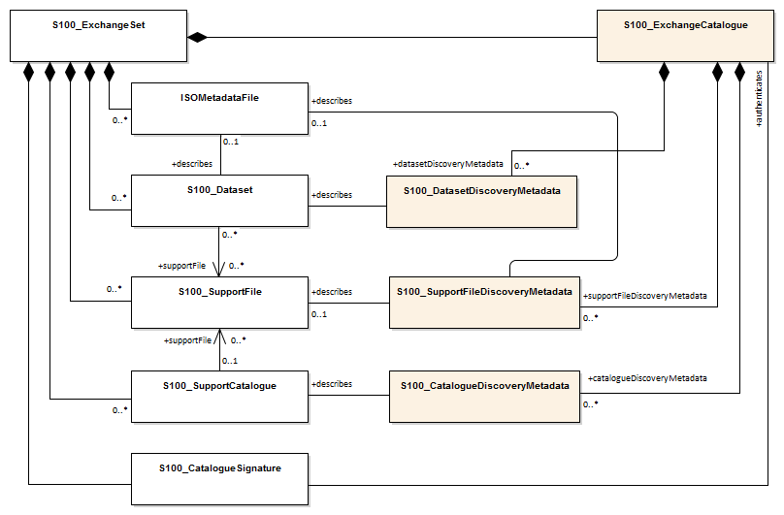

Figure 13.1 - Components and associated metadata for the S-131 exchange set (S-100 5.0.0 Figure 17-2)

The rules governing the presence and roles of the exchange set components depicted in Figure 13.1 are given below.

1. Every exchange set must contain an Exchange Catalogue, represented by **S100_ExchangeCatalogue** in Figure 13.1.
2. Dataset discovery metadata (**S100_DatasetDiscoveryMetadata**) must be provided in the exchange catalogue for each S-131 dataset in the exchange set.
3. Catalogue metadata (**S100_CatalogueDiscoveryMetadata**) must be provided in the exchange catalogue for any feature and portrayal catalogues included in the exchange set.
4. S-131 allows exchange sets to include the following types of support files:
   1. Text and picture support files referenced by datasets (**S100_SupportFile**).
   2. Language packs (**S100_SupportFile**).
   3. ISO metadata files (**ISOMetadataFile**).
5. Text and picture support files referenced in a dataset must be included in the exchange set.
6. The inclusion of language packs and ISO metadata files in exchange sets is optional.
7. The file represented by the class **ISOMetadataFile** is an XML file conforming to ISO 19115 3 format as specified in the ISO 19115-3 XML schemas supplied by the ISO. Each ISO metadata file, if present, must correspond to an S-131 dataset in the exchange catalogue.
8. Producers must not depend on ISO metadata files to convey information for ECDIS application processing, since processing these files is not an ECDIS requirement. All information necessary for ECDIS processing must be in CATALOG.XML. ISO metadata may be provided in exchange sets intended for dual-purpose use on ECDIS and another (ISO-aware) application such as some GIS.
9. Language packs are described in S-100 Part 18 and provide translations of feature catalogues.
10. If an ISO metadata file or a language pack is included, a support file discovery metadata block (**S100_SupportFileDiscoveryMetadata**) describing the file must be included in the exchange catalogue. The *supportFileSpecification* field in the discovery block must specify the applicable ISO standard. The ISO metadata file may repeat information in the discovery blocks in the S-100 exchange catalogue. ISO metadata files are not required unless it is necessary to provide S-131 datasets for tools which require metadata in the ISO 19115-1 format.
11. A signature file for the exchange catalogue must also be included in the exchange set (**S100_CatalogueSignature**).

The tangible representations of the structure classes in Figure 13.1 within actual exchange sets are the digital files or folders containing the exchange set, dataset(s), catalogue(s), and support files. The tangible representations of their roles as depicted in Figure 13.1 are the inclusion of the respective components within the exchange set. Documentation tables for the structure classes are not provided since the exchange set structure is described in this clause.

The metadata classes in Figure 13.1 are represented by XML files or XML blocks and are documented in Clause 14.2.

Each Exchange Set consists of one or more MHI datasets with an associated XML metadata file and a single Exchange Catalogue XML file containing metadata. It may also include one or more support files (or no support files). The Exchange Set structure is the same as that described in S-100 Clause 17-4.2.

## Encapsulation

Each dataset must be contained in a physically separate, uniquely identified file on the transfer medium.

An Exchange Set is encapsulated into a form suitable for transmission as packages (such as ZIP archives or files organised within a file system folder/directory structure), containing both the exchange catalogue and one or more data products (of possibly different S-100 types), with each product covering a specific geographic region and specific period of time.

The contents of an Exchange Set are :

* Mandatory elements
  + Exchange Catalogue – the XML encoded description of the content of the Exchange Set (discovery metadata).
* Optional elements
  + S-131 datasets - Since it is possible for an exchange set to contain only a feature or portrayal catalogue, or only a support file which is being updated or delivered as a new file, datasets are an optional component of S-131 exchange sets.
  + Supplementary files – These are contained within the Exchange Set as files. If the exchange set contains a dataset, the support files referenced in the dataset must be included.
  + S-131 Feature Catalogue – If it is necessary to deliver the latest Feature Catalogue to the end user it may be done using the S-131 Exchange Set mechanism for datasets.
  + S-131 Portrayal Catalogue – If it is necessary to deliver the latest Portrayal Catalogue to the end user it may be done using the S-131 Exchange Set mechanism for datasets.

## Dataset

### Types of Datasets

Table 13.1 lists the types of datasets which may be produced and contained within an exchange set. The corresponding value of the dataset discovery metadata “purpose” field and the format are also described.

Table 13.1 - Types of datasets

|  |  |  |  |
| --- | --- | --- | --- |
| **Dataset Type** | **Explanation** | **Encoding Format** | **“purpose” field** |
| New dataset | Data for an area different (in coverage and/or extent) from existing datasets. | Clause 12 | *newDataset* |
| Re-issue | Includes all the updates applied to the original dataset up to the date of the reissue. A Re-issue is intended to avoid unnecessary loading of the Base cell and all applicable updates individually for new users of the dataset, and therefore does not contain any new information additional to that previously distributed by updates. A reissue dataset can be issued at any time. | As for new dataset | *reissue* |
| New Edition of a dataset | A re-issue plus new information which has not been previously distributed by Updates. Each New Edition of a dataset must have the same name as the dataset that it replaces and should have the same spatial extents. The edition number in the dataset discovery metadata must increment up by one from the previous edition. | As for new dataset | *newEdition* |
| Update dataset | A delta change of the latest edition of a dataset. If there is more than one update dataset, the subsequent update will be a delta of the base dataset + earlier update datasets. | As for new dataset. See Clause 12.14. | *update* |
| Cancellation | Used to cancel dataset and any related update datasets. The dataset is cancelled and is deleted from the system.  A cancellation dataset must be a pro-forma dataset containing only header information (no instances of spatial objects, information types, or feature types). | As for new dataset, but containing only header information. | *cancellation* |

### Dataset file naming

All dataset files will have unique world-wide file identifiers. The file identifier of the dataset should not be used to describe the physical content of the file. The dataset file metadata that accompanies the file will inform the user of the name and purpose of the file (Clause 13.3.1).

S-131 dataset files for new, reissue, new editions, and cancellation datasets are named according to the specifications given below:

131CCCCXXXXXXXXXX.GML

The main part forms an identifier where:

* The first three characters are always “131” and identify the dataset as an S-131 dataset.
* The next four characters identify the issuing agency by its alphanumeric agency code in the IHO producer code register in the IHO GI Registry (i.e., the IHO is identified as “AA”, not “1810”). Where the agency code consists of fewer than four characters, sufficient zeros must be suffixed to make the length exactly four characters (e.g., “US00” instead of “US” - note that the 4-character code for IHO is exceptionally “00AA” based on current information about plans for 4-character codes)[3].
* The subsequent characters can be used in any way by the producer to provide a unique file name for the dataset. The following characters are allowed in the dataset name, A to Z, 0 to 9 and the special character _ (underscore).
* The ninth and subsequent characters are optional (i.e., at least one character must be used after the producer code).
* The maximum length of the file name must be 64 characters including the extension and its preceding ‘.” character. Note that since update datasets must follow the same rule, allowing for updates lowers this limit (e.g., allowing for 999 updates reduces the limit for base datasets by 4 characters).

### Update dataset naming convention

All update dataset files will have an identical name to the base dataset, aside from the separator and update number sequence.

S-131 update dataset files are named according to the specifications given below:

131CCCCXXXXXXXXXX_XXX.GML

The main part forms an identifier where:

* The first character up to the final underscore character are the same as the dataset being updated and therefore conform to the rules described in clause 13.3.2.
* The next character must be an underscore “_”.
* The next three characters must be numerical (0-9) characters to indicate the place of the update dataset in the update sequence.
* The maximum length of the name must be 64 characters including the extension and its preceding “.” character.

### New Editions, re-issues, updates and cancellations

This section defines the sequencing of S-131 datasets for New Editions, updates and re-issues. In order to ensure that feature type updates are incorporated into an end user system in the correct sequence without any omission, a number of parameters encoded in the data are used in the following way:

**Edition number** When a dataset is initially created (Base dataset), the Edition number 1 is assigned to it. The Edition number is increased by 1 at each New Edition.

**Update number** Update number 0 is assigned to a new dataset and a New Edition. The first update dataset file associated with this new dataset must have update number 1. The update number must be increased by one for each subsequent update, until a New Edition is released.

A re-issue of a dataset must have the update number of the last update applied to the dataset, and use the same Edition number.

**Update comment** Comment for describing the change introduced by an update.

**Issue date** Date up to which the Data Producer has incorporated all applicable changes. The issue date must be greater than the previous issue date of the dataset.

In order to cancel a dataset, an update dataset file is created for which the Edition number must be set to 0. This message is only used to cancel a dataset. Where a dataset is cancelled and its name is reused at a later date, the issue date must be greater than the issue date of the cancelled dataset. When the dataset is cancelled it must be removed from the system.

An Exchange Set may contain Base dataset files and update dataset files for the same datasets. Under these circumstances the update dataset files must follow on in the correct sequential order from the last update applied to the Base dataset file.

### Exchange set structure

The structure of an S-131 exchange set must be according to the structure described below, which is based on S-100 Clause 17-4.2. The S-131 exchange set structure is depicted in Figure 13.2.

1. All content must be placed inside a top root folder named S100_ROOT. This is the only top level root folder in an exchange set containing only S-100 products.
2. The S100_ROOT folder must contain a subfolder for S-131 which holds content specific to S-131.
3. An S-131 exchange set must contain an exchange set catalogue, CATALOG.XML, its digital signature CATALOG.SIGN and may contain any number of S-131 conformant dataset files and catalogue files.
4. The S-131 subfolder must contain subfolders for the component dataset files (DATASET_FILES), support files (SUPPORT_FILES), and catalogues (CATALOGUES) as required:
   1. The DATASET_FILES subfolder is required if and only if the exchange set contains an S-131 dataset.
   2. The CATALOGUES subfolder is required if and only if the exchange set contains a feature, interoperability, or portrayal catalogue.
   3. The SUPPORT_FILES folder is required if and only if the exchange set contains at least one S-131 support file.
5. The DATASET_FILES folder must contain a subfolder named according to the producer code.
6. Individual data files must be placed under the producer subfolder, either directly in the producer folder, or within a lower-level subfolder hierarchy. Individual data files may be optionally placed in their own subfolders or grouped with other data files.
7. An exchange set may carry feature and portrayal catalogues in different versions, which should also be grouped together in the CATALOGUES folder.
8. If a portrayal catalogue is included in the exchange set, it may be packaged as either a ZIP archive containing all portrayal catalogue files, or a filesystem structure of folders and files. The structure of portrayal catalogues is described in S-100 Part 9 Clause 9-13.2.
9. Except for the signature of the exchange catalogue file (CATALOG.XML), which is in the CATALOG.SIGN file, all digital signatures are included within their corresponding resource metadata records in CATALOG.XML.
10. Dataset and catalogue file and/or folder names should be such as to avoid inadvertent overwriting of files.
11. Digital signatures for exchange sets conforming to Edition 1.0.0 of S-131 may be dummy values (values that conform to the format requirements but are not actual signatures). Proper digital signatures will be mandatory when S-131 reaches Readiness Level 3 (cf. S-97 1.1.0 Clause A-5).

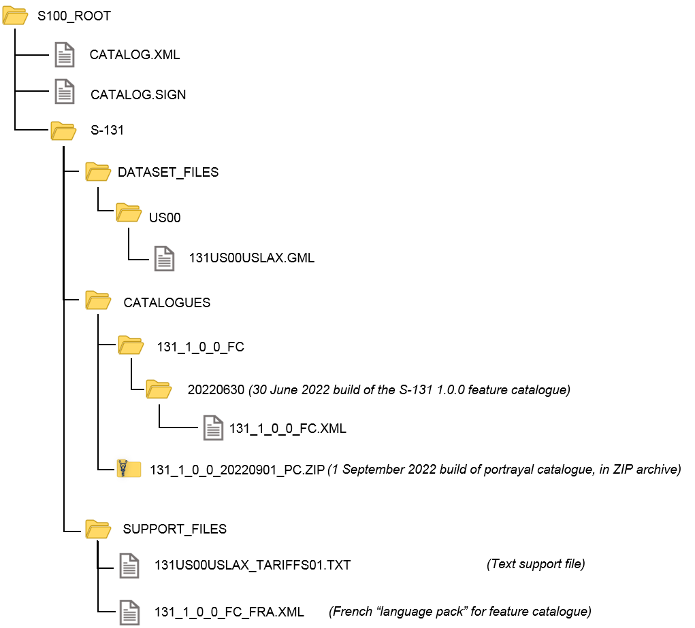

Figure 13.2 - Typical Exchange Set structure

## Support files

Dataset support files offer supplementary information that can be included in an MHI Exchange Set.

* Plain text files must contain only general text as defined by this standard (text consisting only of printable characters and without HTML, XML, or other markup). The extension must be TXT.
* HTML and XML files must contain only text and markup as defined in the relevant W3C standards. Files must use the UTF-8 character set encoding. References in datasets to HTML and XML support files must treat them as text files (i.e., they should not be referenced using attributes intended for picture files). The extension must be HTM for HTML files and XML for general XML files.
* Picture files must be in TIFF (6.0 specification) and use the extension TIF.

Table 13.2 - Support file formats and extensions

|  |  |  |
| --- | --- | --- |
| **File Types** | **Extensions** | **Comment** |
| **Text** | TXT | Plain-text files |
| HTM | HTML files must only include inline or embedded Cascading Style Sheet (CSS) information and must not contain embedded Javascript or other dynamic content, for example DHTML, Flash etc. |
| XML | XML documents must only be included in accordance with guidance provided within the Data Classification and Encoding Guide (Annex A). This may include a Schema for the validation of XML documents. |
| **Picture** | TIF | Baseline TIFF 6.0. |

### Support File Naming

All support files must have unique file identifiers. The support file metadata that accompanies the file will inform the user of the name and purpose of the file (that is new, replacement and deletion).

In this encoding the support files are named according to the specifications given below:

131CCCCØØØØØØØØØØ.EEE

The main part forms an identifier where:

* 131 – the first 3 characters identify the support file as applicable to an S-101 dataset (mandatory).
* CCCC – the fourth to seventh characters identify the Producer Code of the issuing agency (mandatory). Where the Producer Code is derived from a 2 or 3 character format (for instance when converting S-57 ENCs), the missing characters of the Producer Code must be populated with zeros (“00” or “0” respectively) for the sixth and seventh characters of the support file name, as required.
* ØØØØØØØØØØ – the eighth and following characters are optional and can be used in any way by the Producer to provide the unique support file name. The following characters are allowed in the support file name: A to Z, 0 to 9 and the special character _ (underscore).
* .EEE – support file extension. (TXT, HTM, XML or TIF).
* The maximum length of the file name (including the extension and preceding “.”) is 64 characters.

### Support file management

When a support file is created or a subsequent version is issued it must carry its own issue date and be supported with a digital signature which authenticates it against the Producer’s public key included in the Exchange Set metadata.

The type of support file is indicated in the “purpose” field of the discovery metadata. Three types: new, replacement and deletion are defined. Support files carrying the “deletion” flag must be removed from the system. When a feature pointing to a text, picture or application file is deleted or updated so that it no longer references the file, the system software must check to see whether any other feature references the same file, before that file is deleted.

Each support file required must be included only once in the Exchange Set.

Support files must be stored in a separate folder within the Exchange Set, refer to Figure 13.2 – Typical Exchange Set structure.

Re-use of a support file name after a deletion period is possible only if the support file edition number is higher than the previous edition number before deletion.

Only the latest edition of a support file can be used. As soon as a New Edition is created and installed, the older version is retired and can no longer be used by any feature.

If a support file is associated with multiple features in one or several datasets, a New Edition of the file will immediately be used by all associated features.

Picture and text files are treated differently with respect to changes not applicable to all features or information types referencing the support file.

1. **Picture files**: If a New Edition of a picture support file contains changes not applicable to all features or information type instances that reference the original picture, a completely new picture file must be created. Updates changing the file reference in the feature or information type instances that use the new picture must be generated and distributed as updates to the appropriate datasets.
2. **Text files**: The possibility that different feature or information type instances reference different portions of the file (by means of *fileLocator* attributes) must be taken into account.
   1. For plain-text files (TXT), since users may see additional portions of the file as well as the specific section referenced, the same criteria as picture files must be applied and a new TXT file created if there are objects that still need the old information.
   2. For HTML and XML files, instances may have *fileLocator* attributes that point to either HTML “anchors” (i.e., bookmarks) or specific sections identified by an “id” attribute. If some instances still need to reference the old information, there are two possible solutions:
      1. An updated support file can be created with the new information added in a new section of the file, identified by a new “HTML anchor” or “id” attribute. Feature and information type instances that need to reference the changed information must have their *fileLocator* values updated to reference the new section or bookmark.
      2. A new support file can be created and feature and information type instances that need to reference the new information must have their *fileReference* and *fileLocator* attributes updated.
   3. If there are no *fileLocator* attributes in referencing instances, a new support file may be created or the existing support file may be updated to add the new information and facilitate locator attributes by adding HTML anchors or XML id attributes. The affected feature or information type instances must be updated accordingly.
3. In all cases, the file content must be reviewed and updated to ensure that there is no possibility of reader confusion. For example, if a regulation changes only for some regions, a sentence to the effect that “Revised for regions X, Y, and Z effective from (date)” may be added.

The potential necessity of appropriate changes in referencing instances should also be considered, for example to picture caption or *headline* attributes.

In deciding between options, producers should consider the expected lifetime of support files and the effects on update frequency for both datasets and support files, especially in connection with removal of obsolete information from the system as a whole as well as the removal of obsolete sections within support files.

## Exchange Catalogue

The Exchange Catalogue acts as the table of contents for the Exchange Set. The Catalogue file of the Exchange Set must be named CATALOG.XML. No other file in the Exchange Set may be named CATALOG.XML. The contents of the S-131 Exchange Catalogue are described in Clause 14.

## Dataset loading

Datasets must always be loaded in the order of base dataset first, then update datasets in the corrected sequential order. Systems are not to load updates out of order, for example if update 1-5 is present, then 6 is missing, update 7 must not be loaded.

### New editions

When a new edition of a dataset is received, the system must replace the previous edition, along with any updates with the new edition of the dataset. Loading of subsequent updates follows the same rule as above.

## Dataset size

MHI datasets must not exceed 20MB.

Update datasets must not exceed 500KB.

## Data integrity and encryption

Out of scope for S-131 Edition 1.0.0. Under development by S-100WG and will be included for Edition 2.0.0.

# Metadata

## Introduction

For information exchange, there are several categories of metadata required:

* metadata about the overall exchange set and catalogue;
* discovery metadata about each of the datasets contained in the catalogue; and
* discovery metadata about the support files that make up the package.

The discovery metadata classes have numerous attributes which enable important information about the datasets and accompanying support files to be examined without the need to process the data, for example, decrypt, decompress, load, etc.

Discovery metadata for each dataset is given in an XML block within the exchange set catalogue file, and can be accessed without opening the GML dataset file. Discovery metadata is described in Clause 14.2.

Since S-131 does not add product-specific metadata attributes, the S-100 metadata classes and schema are used in S-131 exchange sets without extension. The constraints S-131 imposes on generic S-100 metadata are included in Clause 14.2, generally as remarks describing the extra conditions and restrictions imposed by S-131 (such as making an optional attribute mandatory).

The S-131 product specification package includes an implementation of the S-131 constraints on metadata attributes as Schematron rules in files available from the IHO schema server. The generic S-100 schemas distribution includes a similar implementation of “sanity checks” and S-100 constraints However, neither S-100 not S-131 mandate use of Schematron processors or the distributed Schematron rule files in implementations. Implementers may substitute any implementation method to apply or check constraints instead of using a Schematron-capable processor, including re-encoding the constraints in any suitable implementation-specific language.

This clause defines the mandatory and optional metadata needed for S-131. In some cases (if provided by the producer or exchange set packager) the metadata may be repeated in a language other than English. See S-100 Part 17 Clauses 17-4.6 - 17-4.8 for guidance on encoding of metadata in languages other than English.

## Discovery metadata

An outline of the overall concept of an S-131 exchange set for the interchange of geospatial data and its relevant metadata is explained in Clause 13. The place of metadata in the exchange set is summarised in Clause 13.1.

Figure 14.1 depicts the structure of the exchange catalogue and its component discovery metadata blocks.

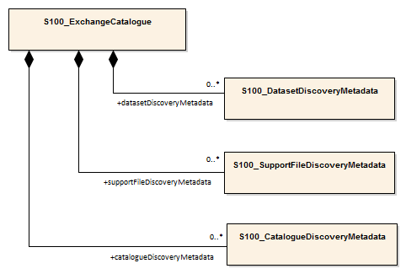

Figure 14.1 - Relationship between exchange catalogue, discovery metadata, and dataset (from S-100 5.0.0 Figure 17-6).

The detailed structure of the S-131 exchange catalogue is depicted in Figure 14.2. This figure is derived from Figure 17-7 in S-100 Edition 5.0.0, with the following restriction:

* Elements that are optional in the generic S-100 catalogue model but not used in S-131 are not shown; for example, the ISO 8211 and HDF5 formats in **S100_EncodingFormat**.

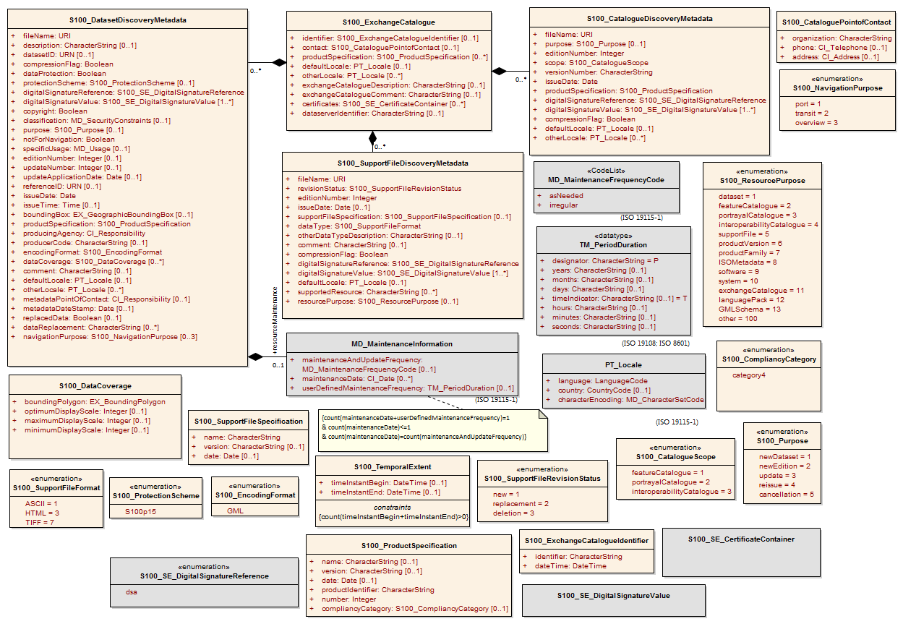

Figure 14.2 - Details of exchange set catalogue classes. (Derived from S-100 Figure 17-7.)

The following clauses define the mandatory and optional metadata needed for S-131. In some cases the metadata may be repeated in a national language. If this is the case it is noted in the Remarks column.

In the following clauses, wherever S-131 makes an optional S-100 metadata attribute mandatory (that is, restricts multiplicity from 0.. to 1..), the restricted multiplicity is shown in place of the multiplicity given in S-100 Part 17. When this is done, the Remarks column contains a note about the restriction. Further, enumerations in the figure and the following clauses show only the values allowed in S-131 Exchange Catalogues. These differences from the S-100 generic metadata are in red bold font.

### S100_ExchangeCatalogue

The Catalogue file is defined in XML Schema language. The Exchange Catalogue inherits the dataset discovery metadata and support file discovery metadata from S-100 with additional S-131-specific restrictions.

| **Role Name** | **Name** | **Description** | **Mult** | **Type** | **Remarks** |
| --- | --- | --- | --- | --- | --- |
| Class | S100_ExchangeCatalogue | An exchange catalogue contains the discovery metadata about the exchange datasets and support files | - | - | **The optional S-100 attributes *identifier*, *contact*, and *productSpecification* are mandatory in S-131.** |
| Attribute | identifier | Uniquely identifies this exchange catalogue | **1** | S100_ExchangeCatalogueIdentifier | **Mandatory in S-131.** |
| Attribute | contact | Details about the issuer of this exchange catalogue | **1** | S100_CataloguePointOfContact | **Mandatory in S-131.** |
| Attribute | productSpecification | Details about the product specifications used for the datasets contained in the exchange catalogue | **1** | S100_ProductSpecification | **Mandatory in S-131**. |
| Attribute | defaultLocale | Default language and character set used for all metadata records in this Exchange Catalogue | 0..1 | PT_Locale | Default is English and UTF-8 |
| Attribute | otherLocale | Other languages and character sets used for the localized metadata records in this Exchange Catalogue | 0..* | PT_Locale | Required if any localized entries are present in the Exchange Catalogue |
| Attribute | exchangeCatalogueDescription | Description of what the exchange catalogue contains | 0..1 | CharacterString |  |
| Attribute | exchangeCatalogueComment | Any additional Information | 0..1 | CharacterString |  |
| Attribute | certificates | Signed public key certificates referred to by digital signatures in the Exchange Set | 0..* | S100_SE_CertificateContainer | Content defined in S-100 Part 15. All certificates used, except the SA root certificate (installed separately by the implementing system) shall be included |
| Attribute | dataServerIdentifier | Identifies the data server for the permit | 0..1 | CharacterString |  |
| Role | datasetDiscoveryMetadata | Exchange Catalogues may include or reference discovery metadata for the datasets in the Exchange Set | 0..* | Aggregation S100_DatasetDiscoveryMetadata |  |
| Role | catalogueDiscoveryMetadata | Metadata for Catalogue | 0..* | Aggregation S100_CatalogueDiscoveryMetadata | Metadata for the Feature, Portrayal and Interoperability Catalogues, if any |
| Role | supportFileDiscoveryMetadata | Exchange Catalogues may include or reference discovery metadata for the support files in the Exchange Set | 0..* | Aggregation S100_SupportFileDiscoveryMetadata |  |

#### S100_ExchangeCatalogueIdentifier

|  |  |  |  |  |  |
| --- | --- | --- | --- | --- | --- |
| **Role Name** | **Name** | **Description** | **Mult** | **Type** | **Remarks** |
| Class | S100_ExchangeCatalogueIdentifier | An Exchange Catalogue contains the discovery metadata about the exchange datasets and support files | - | - | - |
| Attribute | identifier | Uniquely identifies this Exchange Catalogue | 1 | CharacterString | E.g., US00131_<LOCODE>_20200101 |
| Attribute | dateTime | Creation date and time of the Exchange Catalogue, including time zone | 1 | DateTime | Format: yyyy-mm-ddThh:mm:ssZ |

#### S100_CataloguePointOfContact

|  |  |  |  |  |  |  |
| --- | --- | --- | --- | --- | --- | --- |
| **Role Name** | **Name** | **Description** | **Mult** | | **Type** | **Remarks** |
| Class | S100_CataloguePointOfContact | Contact details of the issuer of this Exchange Catalogue | - | - | | - |
| Attribute | organization | The organization distributing this Exchange Catalogue | 1 | CharacterString | | This could be an individual producer, value added reseller, etc |
| Attribute | phone | The edition number of this Exchange Catalogue | 0..1 | CI_Telephone | |  |
| Attribute | address | The address of the organization | 0..1 | CI_Address | |  |

### S100_DatasetDiscoveryMetadata

| **Role Name** | **Name** | **Description** | **Mult** | **Type** | **Remarks** |
| --- | --- | --- | --- | --- | --- |
| Class | S100_DatasetDiscoveryMetadata | Metadata about the individual datasets in the exchange catalogue | - | - | **The optional S-100 attributes *datasetID,* *editionNumber, updateNumber* and *boundingBox* are mandatory in S-131.**  **The optional S-100 attribute *temporalExtent* is not used.** |
| Attribute | fileName | Dataset file name | 1 | URI | See S-100 Part 1, clause 1-4.6 |
| Attribute | description | Short description giving the area or location covered by the dataset | 0..1 | CharacterString | E.g. a harbour or port name, between two named locations etc. |
| Attribute | datasetID | Dataset ID expressed as a Marine Resource Name | **1** | URN | The URN must be an MRN. **Restricted to mandatory in S-131** |
| Attribute | compressionFlag | Indicates if the resource is compressed | 1 | Boolean | *true* indicates a compressed dataset resource  *false* indicates an uncompressed dataset resource |
| Attribute | dataProtection | Indicates if the data is encrypted | 1 | Boolean | *true* indicates an encrypted dataset resource  *false* indicates an unencrypted dataset resources |
| Attribute | protectionScheme | Specification of method used for data protection | 0..1 | S100_ProtectionScheme | In S-100 Edition 5.0.0 the only allowed value is “S100p15”. |
| Attribute | digitalSignatureReference | Specifies the algorithm used to compute digitalSignatureValue | 1 | S100_DigitalSignatureReference (see S-100 Part 15) |  |
| Attribute | digitalSignatureValue | Value derived from the digital signature | 1..* | S100_DigitalSignatureValue (see S-100 Part 15) | The value resulting from application of *digitalSignatureReference*  Implemented as the digital signature format specified in Part 15 |
| Attribute | copyright | Indicates if the dataset is copyrighted | 1 | Boolean | *true* indicates the resource is copyrighted  *false* Indicates the resource is not copyrighted |
| Attribute | classification | Indicates the security classification of the dataset | 0..1 | MD_SecurityConstraints> MD_ClassificationCode (codelist) | 1. unclassified  2. restricted  3. confidential  4. secret  5. top secret  6. sensitive but unclassified  7. for official use only  8. protected  9. limited distribution |
| Attribute | purpose | The purpose for which the dataset has been issued | 0..1 | S100_Purpose |  |
| Attribute | notForNavigation | Indicates the dataset is not intended to be used for navigation | 1 | Boolean | *true* indicates the dataset is not intended to be used for navigation  *false* indicates the dataset is intended to be used for navigation |
| Attribute | specificUsage | The use for which the dataset is intended | 1 | MD_USAGE>specificUsage (character string) | Information about specific usage(s) for which the dataset is intended. The string value “general” may be encoded if there is no specific usage. |
| Attribute | editionNumber | The edition number of the dataset | **1** | CharacterString | **Mandatory in S-131.** |
| Attribute | updateNumber | Update number assigned to the dataset and increased by one for each subsequent update | **1** | Integer | Update number 0 is assigned to a new dataset  **Made mandatory in S-131.** |
| Attribute | updateApplicationDate | This date is only used for the base cell files (that is new data set, re-issue and new edition), not update cell files. All updates dated on or before this date must have been applied by the producer | 0..1 | Date | This date is only used for the base dataset files (that is new dataset, re-issue and new edition), not update dataset files. All updates dated on or before this date must have been applied by the producer |
| Attribute | referenceID | Reference back to the datasetID | 0..1 | URN | Update metadata refers to the datasetID  of the dataset metadata. This is used if  and only if the dataset is an update  The URN must be an MRN |
| Attribute | issueDate | Date on which the data was made available by the data producer | 1 | Date |  |
| Attribute | issueTime | Time of day at which the data was made available by the data producer | 0..1 | Time | Mandatory when the interval between datasets is shorter than 1 day, such as 6-hourly forecasts. |
| Attribute | boundingBox | The extent of the dataset limits | **1** | EX_GeographicBoundingBox | **Mandatory in S-131.** |
| Attribute | productSpecification | The product specification used to create this dataset | 1 | S100_ProductSpecification |  |
| Attribute | producingAgency | Agency responsible for producing the data | 1 | CI_ResponsibleParty>CI_Organisation | See S-100 Table 17-3 |
| Attribute | producerCode | The official IHO Producer Code from S-62 | 0..1 | CharacterString |  |
| Attribute | encodingFormat | The encoding format of the dataset | 1 | S100_EncodingFormat | **Must be GML** |
| Attribute | dataCoverage | Area covered by the dataset | **1**..* | S100_DataCoverage | **Mandatory in S-131.** |
| Attribute | comment | Any additional information | 0..1 | CharacterString |  |
| Attribute | defaultLocale | Default language and character set used in the exchange catalogue | 1 | PT_Locale |  |
| Attribute | otherLocale | Other languages and character sets used in the exchange catalogue | 0..* | PT_Locale |  |
| Attribute | metadataPointOfContact | Point of contact for metadata | 0..1 | CI_Responsibility > CI_Individual or CI_Responsibility > CI_Organisation | Only if metadataPointOfContact is  different from producingAgency.  See S-100 Tables 17-2 and 17-3. |
| Attribute | metadataDateStamp | Date stamp for metadata | 0..1 | Date | May or may not be the issue date of the dataset. |
| Attribute | replacedData | If a data file is cancelled is it replaced by another data file | 0..1 | Boolean |  |
| Attribute | dataReplacement | Cell name | 0..* | CharacterString | A dataset may be replaced by 1 or more datasets |
| Attribute | navigationPurpose | Classification of intended navigation purpose (for Catalogue indexing purposes) | 0..3 | S100_NavigationPurpose | Mandatory when *notForNavigation* = *false*. |
| Role | resourceMaintenance | Information about the frequency of resource updates, and the scope of those updates | 0..1 | MD_MaintenanceInformation | S-100 restricts the multiplicity to 0..1  and adds specific restrictions on the ISO 19115 structure and content. See  clause **MD_MaintenanceInformation**  in S-100 Part 17.  Format: PnYnMnDTnHnMnS (XML built-in type for ISO 8601 duration). See S-100 clause 17-4.9 for encoding guidance. |

#### S100_NavigationPurpose

|  |  |  |  |  |
| --- | --- | --- | --- | --- |
| **Role Name** | **Name** | **Description** | **Code** | **Remarks** |
| Enumeration | S100_NavigationPurpose | The purpose of the dataset | - |  |
| Value | port | For port and near shore operations | 1 | - |
| Value | transit | For coast and planning purposes | 2 | - |
| Value | overview | For ocean crossing and planning purposes | 3 | - |

#### S100_DataCoverage

|  |  |  |  |  |
| --- | --- | --- | --- | --- |
| **Name** | **Description** | **Multiplicity** | **Type** | **Remarks** |
| S100_DataCoverage | A spatial extent where data is provided; and the display scale information for the provided data | - | - | **The optional S-100 attributes *temporalExtent* and *approximateGridResolution* are not used in S-131.** |
| boundingPolygon | A polygon which defines the actual data limit | 1 | EX_BoundingPolygon |  |
| optimumDisplayScale | The scale with which the data is optimally displayed | 0..1 | Integer | Example: A scale of 1:25000 is encoded as 25000 |
| maximumDisplayScale | The maximum scale with which the data is displayed | 0..1 | Integer | Must be one of the following values:  1000  2000  3000  4000  8000  12000  22000  45000  90000  180000  350000  700000  1500000  3500000  10000000 |
| minimumDisplayScale | The minimum scale with which the data is displayed | 0..1 | Integer | Must be one of the following values:  2000  3000  4000  8000  12000  22000  45000  90000  180000  350000  700000  1500000  3500000  10000000 |

#### S100_Purpose

| **Role Name** | **Name** | **Description** | **Code** | **Remarks** |
| --- | --- | --- | --- | --- |
| Enumeration | S100_Purpose | The purpose of the dataset | - | **The value *delta* is not used.** |
| Value | newDataset | Brand new dataset | 1 | No data has previously been produced for this area |
| Value | newEdition | New edition of the dataset or Catalogue | 2 | Includes new information which has not been previously distributed by updates |
| Value | update | Dataset update | 3 | Changing some information in an existing dataset |
| Value | reissue | Dataset that has been re-issued | 4 | Includes all the updates applied to the original dataset up to the date of the re-issue. A re-issue does not contain any new information additional to that previously issued by updates |
| Value | cancellation | Dataset or Catalogue that has been cancelled | 5 | Indicates the dataset or Catalogue should no longer be used and can be deleted |

#### S100_VerticalAndSoundingDatum

This is used by the meta-features for sounding and vertical datums. This enumeration is not depicted in Figure 14.2 because it is not used in the exchange catalogue.

|  |  |  |  |  |
| --- | --- | --- | --- | --- |
| **Role Name** | **Name** | **Description** | **Code** | **Remarks** |
| Enumeration | S100_VerticalAndSoundingDatum | Allowable vertical and sounding datums | - | **Values listed in S-100 Part 17 but not mentioned in this table are not allowed** |
| Value | meanLowWaterSprings |  | 1 | (MLWS) |
| Value | meanLowerLowWaterSprings |  | 2 |  |
| Value | meanSeaLevel |  | 3 | (MSL) |
| Value | lowestLowWater |  | 4 |  |
| Value | meanLowWater |  | 5 | (MLW) |
| Value | lowestLowWaterSprings |  | 6 |  |
| Value | approximateMeanLowWaterSprings |  | 7 |  |
| Value | indianSpringLowWater |  | 8 |  |
| Value | lowWaterSprings |  | 9 |  |
| Value | approximateLowestAstronomicalTide |  | 10 |  |
| Value | nearlyLowestLowWater |  | 11 |  |
| Value | meanLowerLowWater |  | 12 | (MLLW) |
| Value | lowWater |  | 13 | (LW) |
| Value | approximateMeanLowWater |  | 14 |  |
| Value | approximateMeanLowerLowWater |  | 15 |  |
| Value | meanHighWater |  | 16 | (MHW) |
| Value | meanHighWaterSprings |  | 17 | (MHWS) |
| Value | highWater |  | 18 | (HW) |
| Value | approximateMeanSeaLevel |  | 19 |  |
| Value | highWaterSprings |  | 20 |  |
| Value | meanHigherHighWater |  | 21 | (MHHW) |
| Value | equinoctialSpringLowWater |  | 22 |  |
| Value | lowestAstronomicalTide |  | 23 | (LAT) |
| Value | localDatum |  | 24 |  |
| Value | internationalGreatLakesDatum1985 |  | 25 |  |
| Value | meanWaterLevel |  | 26 |  |
| Value | lowerLowWaterLargeTide |  | 27 |  |
| Value | higherHighWaterLargeTide |  | 28 |  |
| Value | nearlyHighestHighWater |  | 29 |  |
| Value | highestAstronomicalTide |  | 30 | (HAT) |
| Value | balticSeaChartDatum2000 |  | 44 |  |
| Value | internationalGreatLakesDatum2020 | The 2020 update to the International Great Lakes Datum, the official reference system used to measure water level heights in the Great Lakes, connecting channels, and the St. Lawrence River system | 46 | Unlike the previous two IGLDs, this datum update will use a geoid-based vertical datum that will be accessible using global navigation satellite systems (GNSS) such as the Global Positioning System (GPS) |

NOTE: The numeric codes are the codes specified in the IHO GI Registry for the equivalent listed values of the IHO Hydro domain attribute *Vertical Datum*.

#### S100_EncodingFormat

|  |  |  |  |  |
| --- | --- | --- | --- | --- |
| **Role Name** | **Name** | **Description** | **Code** | **Remarks** |
| Enumeration | S100_EncodingFormat | The encoding format | - | **Values listed in S-100 Part 17 but not mentioned in this table are not allowed** |
| Value | GML | The GML data format as defined in S-100 Part 10b |  |  |

#### S100_ProductSpecification

| **Role Name** | **Name** | **Description** | **Mult** | **Type** | **Remarks** |
| --- | --- | --- | --- | --- | --- |
| Class | S100_ProductSpecification | The Product Specification contains the information needed to build the specified product | - | - | **The attribute *compliancyCategory* is made mandatory.** |
| Attribute | name | The name of the Product Specification used to create the datasets | 0..1 | CharacterString | Marine Harbour Infrastructure |
| Attribute | version | The version number of the Product Specification | 0..1 | CharacterString | 1.0.0 |
| Attribute | date | The version date of the Product Specification | 0..1 | Date |  |
| Attribute | productIdentifier | Machine readable unique identifier of a product type | 1 | CharacterString  (Restricted to Product ID values from the IHO Product Specification Register, in the IHO Geospatial Information (GI) Registry) | “S-131” (without quotes) |
| Attribute | number | The number (registry index) used to lookup the product in the Product Specification Register | 1 | Integer | From the Product Specification Register in the IHO Geospatial Information (GI) Registry |
| Attribute | compliancyCategory | The level of compliance of the Product Specification to S-100 | **1** | S100_CompliancyCategory | Needed for S-98 interoperability. |

#### S100_CompiancyCategory

|  |  |  |  |  |
| --- | --- | --- | --- | --- |
| **Role Name** | **Name** | **Description** | **Code** | **Remarks** |
| Enumeration | S100_CompliancyCategory |  | - | **S-131 uses only *category4*** |
| Value | category4 | IHO S-100 and IMO harmonized display compliant |  |  |

#### S100_ProtectionScheme

|  |  |  |  |  |
| --- | --- | --- | --- | --- |
| **Role Name** | **Name** | **Description** | **Code** | **Remarks** |
| Enumeration | S100_ProtectionScheme | Data protection schemes | - | - |
| Value | S100p15 | IHO S-100 Part 15 | - | See S-100 Part 15 |

### S100_SupportFileDiscoveryMetadata

|  |  |  |  |  |  |
| --- | --- | --- | --- | --- | --- |
| **Role Name** | **Name** | **Description** | **Mult.** | **Type** | **Remarks** |
| Class | S100_SupportFileDiscoveryMetadata | Metadata about the individual support files in the Exchange Catalogue | - | - |  |
| Attribute | fileName | Name of the support file | 1 | URI | See S-100 Part 1, clause 1-4.6 |
| Attribute | revisionStatus | The purpose for which the support file has been issued | 1 | S100_SupportFileRevisionStatus | For example new, replacement, etc |
| Attribute | editionNumber | The Edition number of the support file | 1 | Integer |  |
| Attribute | issueDate | Date on which the data was made available by the Data Producer | 0..1 | Date | Date on which the support file was made available by its producer. |
| Attribute | supportFileSpecification | The specification used to create this file | 0..1 | S100_SupportFileSpecification | May be omitted for language packs. |
| Attribute | dataType | The format of the support file | 1 | S100_SupportFileFormat |  |
| Attribute | otherDataTypeDescription | Support file format other than those listed | 0..1 | CharacterString |  |
| Attribute | comment | Optional comment | 0..1 | CharacterString |  |
| Attribute | compressionFlag | Indicates if the resource is compressed | 1 | Boolean | *true* indicates a compressed resource  *false* indicates an uncompressed resource |
| Attribute | digitalSignatureReference | Specifies the algorithm used to compute digitalSignatureValue | 1 | S100_DigitalSignatureReference  (see Part 15) |  |
| Attribute | digitalSignatureValue | Value derived from the digital signature | 1..* | S100_DigitalSignatureValue  (see Part 15) | The value resulting from application of digitalSignatureReference  Implemented as the digital signature format specified in S-100 Part 15 |
| Attribute | defaultLocale | Default language and character set used in the support file | 0..1 | PT_Locale | In absence of defaultLocale the language is English in UTF-8  A support file is expected to use only one as locale. Additional support files can be created for other locales. |
| Attribute | supportedResource | Identifier of the resource supported by this support file | 0..* | CharacterString | Conventions for identifiers are still to be developed in S-100.  In the interim, S-131 will use the name of the feature catalogue file or the name of the dataset, as appropriate. |
| Attribute | resourcePurpose | The purpose of the supporting resource | 0..1 | S100_ResourcePurpose | Identifies how the supporting resource is used |

#### S100_SupportFileFormat

|  |  |  |  |  |
| --- | --- | --- | --- | --- |
| **Role Name** | **Name** | **Description** | **Code** | **Remarks** |
| Enumeration | S100_SupportFileFormat | The format used for the support file | - | **Values listed in S-100 Part 17 but not mentioned in this table are not allowed** |
| Value | ASCII | UTF-8 text excluding control codes | 1 | Text |
| Value | HTML | Hypertext Markup Language | 3 |  |
| Value | XML | Extensible Markup Language | 4 |  |
| Value | TIFF | Tagged Image File Format | 7 |  |

#### S100_SupportFileRevisionStatus

|  |  |  |  |  |
| --- | --- | --- | --- | --- |
| **Role Name** | **Name** | **Description** | **Code** | **Remarks** |
| Enumeration | S100_SupportFileRevisionStatus | The reason for inclusion of the support file in this exchange set | - | - |
| Value | new | A file which is new | 1 | Signifies a new file |
| Value | replacement | A file which replaces an existing file | 2 | Signifies a replacement for a file of the same name |
| Value | deletion | Deletes an existing file | 3 | Signifies deletion of a file of that name |

#### S100_SupportFileSpecification

|  |  |  |  |  |  |
| --- | --- | --- | --- | --- | --- |
| **Role Name** | **Name** | **Description** | **Mult** | **Type** | **Remarks** |
| Class | S100_SupportFileSpecification | The standard or specification to which a support file conforms | - | - | - |
| Attribute | name | The name of the specification used to create the support file | 1 | CharacterString |  |
| Attribute | version | The version number of the specification | 0..1 | CharacterString |  |
| Attribute | date | The version date of the specification | 0..1 | Date |  |

#### S100_ResourcePurpose

|  |  |  |  |  |
| --- | --- | --- | --- | --- |
| **Role Name** | **Name** | **Description** | **Code** | **Remarks** |
| Enumeration | S100_ResourcePurpose | Defines the purpose of the supporting resource | - | - |
| Value | dataset | A dataset | 1 |  |
| Value | featureCatalogue | A Feature Catalogue for an S-100 data product | 2 |  |
| Value | portrayalCatalogue | A Portrayal Catalogue for an S-100 data product | 3 |  |
| Value | interoperabilityCatalogue | An Interoperability Catalogue | 4 |  |
| Value | supportFile | A support file | 5 |  |
| Value | productVersion | All datasets conforming to a specific version of an S-100 Product Specification | 6 |  |
| Value | productFamily | All datasets conforming to any active version of an S-100 Product Specification | 7 |  |
| Value | software | Application software | 8 |  |
| Value | system | Provides support or common information for a variety of applications and products | 9 |  |
| Value | exchangeCatalogue | An Exchange Catalogue | 10 |  |
| Value | ISO Metadata | Dataset metadata in ISO format | 11 |  |
| Value | Language Pack | A Language pack | 12 |  |
| Value | GML Schema | GML Application Schema | 13 |  |
| Value | other | A type of resource not otherwise described | 100 |  |

### S100_CatalogueDiscoveryMetadata

This is an optional element that allows for the delivery of S-131 Feature and Portrayal Catalogues within the Exchange Set.

|  |  |  |  |  |  |
| --- | --- | --- | --- | --- | --- |
| **Role Name** | **Name** | **Description** | **Mult** | **Type** | **Remarks** |
| Class | S100_CatalogueDiscoveryMetadata | Class for S-100 Catalogue metadata | - | - | - |
| Attribute | fileName | The name for the Catalogue | 1 | URI | See S-100 Part1, clause 1-4.6 |
| Attribute | purpose | The purpose for which the Catalogue has been issued | 0..1 | S100_Purpose  (codelist) | The values must be one of the following:  *2* new edition  *5* cancellation  Default is new edition |
| Attribute | editionNumber | The Edition number of the Catalogue | 1 | Integer | Initially set to 1 for a given productSpecification.number  Increased by 1 for each subsequent newEdition  Uniquely identifies the version of the Catalogue |
| Attribute | scope | Subject domain of the Catalogue | 1 | S100_CatalogueScope |  |
| Attribute | versionNumber | The version identifier of the Catalogue | 1 | CharacterString | Human readable version identifier |
| Attribute | issueDate | The issue date of the Catalogue | 1 | Date |  |
| Attribute | productSpecification | The Product Specification used to create this file | 1 | S100_ProductSpecification |  |
| Attribute | digitalSignatureReference | Specifies the algorithm used to compute digitalSignatureValue | 1 | S100_DigitalSignatureReference  (see S-100 Part 15) |  |
| Attribute | digitalSignatureValue | Value derived from the digital signature | 1..* | S100_DigitalSignatureValue  (see S-100 Part 15) | The value resulting from application of *digitalSignatureReference*  Implemented as the digital signature format specified in Part 15 |
| Attribute | compressionFlag | Indicates if the resource is compressed | 1 | Boolean | *true* indicates a compressed resource  *false* indicates an uncompressed resource |
| Attribute | defaultLocale | Default language and character set used in the Catalogue | 0..1 | PT_Locale | In absence of *defaultLocale* the language is English in UTF-8 |
| Attribute | otherLocale | Other languages and character sets used in the Catalogue | 0..* | PT_Locale |  |

#### S100_CatalogueScope

|  |  |  |  |  |
| --- | --- | --- | --- | --- |
| **Role Name** | **Name** | **Description** | **Code** | **Remarks** |
| Enumeration | S100_CatalogueScope | The scope of the Catalogue | - | - |
| Value | featureCatalogue | S-100 Feature Catalogue | 1 |  |
| Value | portrayalCatalogue | S-100 Portrayal Catalogue | 2 |  |
| Value | interoperabilityCatalogue | S-100 Interoperability Catalogue | 3 |  |

### Miscellaneous metadata types

#### MD_MaintenanceInformation

|  |  |  |  |  |  |
| --- | --- | --- | --- | --- | --- |
| **Role Name** | **Name** | **Description** | **Mult** | **Type** | **Remarks** |
| Class | MD_MaintenanceInformation | Information about the scope and frequency of updating | - | - | S-100 restricts the ISO 19115-class to:   * prohibit maintenanceScope, maintenanceNote, and contact attributes; * define restrictions on maintenanceAndUpdate‌Frequency, maintenanceDate, and userDefinedMaintenance‌Frequency attributes |
| Attribute | maintenanceAndUpdateFrequency | Frequency with which changes and additions are made to the resource after the initial resource is completed | 0..1 | MD_MaintenanceFrequencyCode (codelist) | Must be populated if userDefinedMaintenanceFrequency is not present, otherwise optional. See Table MD_Maintenance‌Frequency‌Code in this Part for values allowed in S-100 metadata |
| Attribute | maintenanceDate | Date information associated with maintenance of the resource | 0..1 | CI_Date | Exactly one of maintenanceDate and userDefinedMaintenanceFrequency must be populated  Allowed value for dateType: nextUpdate |
| Attribute | userDefinedMaintenanceFrequency | Maintenance period other than those defined | 0..1 | TM_PeriodDuration | Exactly one of maintenanceDate and userDefinedMaintenanceFrequency must be populated  Only positive durations allowed |

#### MD_MaintenanceFrequencyCode

S-100 uses a subset of the values allowed in ISO 19115-1.

|  |  |  |  |  |
| --- | --- | --- | --- | --- |
| **Role Name** | **Name** | **Description** | **Code** | **Remarks** |
| Enumeration | MD_MaintenanceFrequencyCode | Frequency with which modifications and deletions are made to the data after it is first produced | - | S-100 is restricted to only the following values from the ISO 19115-1 codelist. The conditions for the use of a particular value are described in its Remarks |
| Value | asNeeded | Resource is updated as deemed necessary | 1 | Use only for datasets which normally use a regular interval for update or supersession, but will have the next update issued at an interval different from the usual  Allowed if and only if userDefinedMaintenanceFrequency is not populated |
| Value | irregular | Resource is updated in intervals that are uneven in duration | 2 | Use only for datasets which do not use a regular schedule for update or supersession  Allowed if and only if userDefinedMaintenanceFrequency is not populated |

#### PT_Locale

|  |  |  |  |  |  |
| --- | --- | --- | --- | --- | --- |
| **Role Name** | **Name** | **Description** | **Mult** | **Type** | **Remarks** |
| Class | PT_Locale | description of a locale | - | - | From ISO 19115-1 |
| Value | language | designation of the locale language | 1 | LanguageCode | ISO 639-2 3-letter language codes. |
| Value | country | designation of the specific country of the locale language | 0..1 | CountryCode | ISO 3166-2 2-letter country codes |
| Value | characterEncoding | designation of the character set to be used to encode the textual value of the locale | 1 | MD_CharacterSetCode | UTF-8 is used in S-100 |

The class PT_Locale is defined in ISO 19115-1. LanguageCode, CountryCode, and MD_CharacterSetCode are ISO codelists which are defined in a resource file in the S-100 5.0 schemas distribution.

#### EX_GeographicBoundingBox

From ISO 19115-1.

| **Role Name** | **Name** | **Description** | **Mult** | **Type** | **Remarks** |
| --- | --- | --- | --- | --- | --- |
| Class | EX_GeographicBoundingBox | geographic position of the dataset | - | - | Defined in ISO 19115-1: geographic position of the resource |
| Attribute | westBoundLongitude | western-most coordinate of the limit of the dataset extent, expressed in longitude in decimal degrees (positive east) | 1 | Real | Arc degrees |
| Attribute | eastBoundLongitude | eastern-most coordinate of the limit of the dataset extent, expressed in longitude in decimal degrees (positive east) | 1 | Real | Arc degrees |
| Attribute | southBoundLatitude | southern-most coordinate of the limit of the dataset extent, expressed in latitude in decimal degrees (positive north) | 1 | Real | Arc degrees |
| Attribute | northBoundLatitude | northern-most, coordinate of the limit of the dataset extent expressed in latitude in decimal degrees (positive north) | 1 | Real | Arc degrees |

#### EX_BoundingPolygon

From ISO 19115-1.

| **Role Name** | **Name** | **Description** | **Mult** | **Type** | **Remarks** |
| --- | --- | --- | --- | --- | --- |
| Class | EX_BoundingPolygon | boundary enclosing the dataset, expressed as the closed set of (x,y) coordinates of the polygon (last point replicates first point) | - | - | Defined in ISO 19115-1: enclosing geometric object which locates the resource, expressed as a set of (x,y) coordinate(s) |
| Attribute | polygon | sets of points defining the bounding polygon | 1 | GM_Object | Must be a GM_Polygon  (See S-100 Part 7, ISO 19107, ISO 19136) |

### Types for digital signatures

The types relating to digital signatures:

* S100_SE_CertificateContainer
* S100_SE_DigitalSignatureReference
* S100_SE_DigitalSignatureValue
* S100_SE_SignatureOnData
* S100_SE_SignatureOnSignature
* DataStatus

are defined in S-100 Part 15 and are used in S-131 without modification.

## Language

The exchange language must be English. Other languages may be used as a supplementary option. National geographic names can be left in their original national language using the complex attribute **feature name**.

Character strings must be encoded using the character set defined in ISO 10646-1, in Unicode Transformation Format-8 (UTF-8). A BOM (byte order mark) must not be used.

# LIST OF ANNEXES

These Annexes are separate files and can be found either in the S-131 Product Specification distribution package or at the locations indicated.

Annex A Data Classification and Encoding Guide. Separate document. IHO Geospatial Information Registry, https://registry.iho.int

Annex B Encoding Format. GML schema, Schematron rule files, and schema documentation. S-100 schema server, https://schemas.s100dev.net.

Annex C Feature catalogue. XML file. IHO Geospatial Information Registry, https://registry.iho.int

Annex D Validation Checks. Separate document. IHO Geospatial Information Registry, https://registry.iho.int

Annex E Portrayal Catalogue. Zip archive of portrayal catalogue. IHO Geospatial Information Registry, https://registry.iho.int

1. Source information is currently broken out into three attributes: source, sourceType, and reportedDate, due to GI Registry issues with the complex attribute sourceIndication.
2. Available from https://schemas.s100dev.net. The XML and human-readable versions of the codelists file for S-100 Edition 5.0.0 are located at https://schemas.s100dev.net/schemas/S100/5.0.0/resources/Codelists/cat/codelists.xml and https://schemas.s100dev.net/schemas/S100/5.0.0/resources/Codelists/cat/codelists.html respectively.
3. Suffixing zeros is a temporary expedient pending conversion of the IHO producer code registry to 4-character codes. When 4-character IHO producer codes are published, they must be used.